Section N

Student Mobility

Contents
Abbreviations in this section 1
Definitions 2
ECTS 2
Erasmus Bilateral Agreement 2
The SAIL Office 2
Exchange Agreement 2
Exchange Coordinators and Administrators 2
Incoming Student Mobility 2
LearningAgreement 2
Outgoing Student Mobility 3
Recognition of periods abroad 3
Turing scheme 3
Purpose 3
Criteria 3
Exchange Partners 3
Student Eligibility 4
Flowchart 4
Establishing new Exchange Agreements 4
Process 5
Proposing new agreements 5
Selecting and documenting outgoing students 7
Credits abroad and transcripts 10
Recognition and grade transfer 10
Incoming Students 10
Oversight and Review 11

Abbreviations in this section
AQSH | Academic Quality and Standards Handbook
ECHE | Erasmus Charter for Higher Education
ECTS | European Credit Transfer and Accumulation System
FMG | Faculty Management Group
HEI | Higher Education Institution
KU | Kingston University
QAE | Quality Assurance and Enhancement
SAIL OFFICE | Study Abroad and International Learning Office

Definitions

ECTS
- Is the European Credit and Accumulation Transfer System which allows cross border recognition of credit awarded at European Universities for comparability and award. ECTS is applied to all programmes, whatever their mode and type of delivery. One ECTS credit is equal to two Kingston University credits and thus the workload for one standard academic year (i.e. 120 credits) is equal to 60 ECTS credits and for one teaching block to 30 ECTS credits. These appear on the HEAR and the Record of Progress.

Erasmus Bilateral Agreement
- This is a document signed by Kingston University and a European institution to exchange students (and/or staff) within the regulations of the Erasmus programme. The agreement includes the field of study, level of students and number and length of stay for mobility. These agreements operate at faculty/subject level.

The SAIL Office
- Is responsible for student mobility within Europe and the rest of the world.

Exchange Agreement
- This is a formal document signed between Kingston University and another Higher Education Institution in order to exchange students with expectations of a reasonable possibility of reciprocity. Most agreements, especially with non-EU HEIs, are institution-wide and can also be replaced by a Memorandum of Understanding including a Mobility Annex.

Exchange Coordinators and Administrators
- Those members of Kingston University staff nominated by their faculty or school to manage the processes under their responsibility.

Incoming Student Mobility
- This includes students who come to Kingston University through an Erasmus Bilateral Agreement, or an Exchange Agreement with the home institution. Exchange students do not pay tuition fees to Kingston University, whereas Study Abroad students (or Study Abroad partner institutions, where the mobility is only to KU), pay tuition fees to KU according to the agreement signed with their home institutions/organisation. All of them remain registered at their home institution while abroad and do not qualify for Kingston University degrees.

Learning Agreement
- Is a document which underpins the student’s learning experience during a period of mobility. Every outgoing student must have a learning agreement approved by the relevant Kingston University faculty and signed by the student prior to the commencement of studies. For incoming students, dependent upon type of agreement, this is done by faculty or the SAIL office.This document outlines all modules/credits to be taken during the period of study abroad.

Outgoing Student Mobility
- This is the opportunity Kingston University students are given to undertake some of their study (both towards a degree and augmenting a degree) or work placement at other institutions and organisations abroad. This includes students who are formally registered at Kingston University at the time of mobility, and have been awarded a place at an institution with which Kingston University has either signed an Erasmus Bilateral Agreement (for European destinations), or an Exchange Agreement (for non-European and a few European destinations).

Recognition of periods abroad
- This is the acceptance into the Kingston University credit system of credits awarded by another university or obtained through a work placement in a company or organisation.

Turing scheme
- Mobility programme created by the UK government to enhance student mobility since 2021-22.

Purpose
- To provide students with the opportunity to study in another country, Kingston University operates Erasmus, Turing and study abroad programmes. The purpose of the processes described in this section of the AQSH are to ensure that students only undertake study abroad schemes with approved partners operating under current Erasmus or Exchange Agreements with Kingston University. The processes involved in drawing up new exchange agreements ensure that the learning and experience of outgoing students is protected. This includes the criteria for eligibility, the application process and the use of learning agreements.

- Erasmus and other exchange agreements are intended to be reciprocal and this section N of the Academic Quality and Standards Handbook briefly describes the process for faculties to prepare for the intake of incoming students.

Criteria

Exchange Partners
- For outgoing Kingston University students, the University is responsible for:
- the academic standards of all of its awards;
- the quality of the learning opportunities provided, regardless of where these opportunities are delivered and who provides them;
- ensuring that there are adequate systems to support the management and administration of all modules; sound and effective quality assurance systems; suitable teaching and learning strategies and access for students to adequate library, computing and other supporting facilities;
- ensuring that the quality of the student experience is comparable for all KU student cohorts, whether studying at the University or at a partner institution;
- ensuring that the information relating to study abroad/Erasmus/Turing arrangements (in any media) is accurate.
- Following the UK departure from the Erasmus programme in December 2020, KU has signed new agreements via the ‘Erasmus Bilateral Agreements among EU Member States and Third Countries associated to the programme’ option, using the template produced by the European Commission or ordinary Exchange Agreements

Student Eligibility
- All Kingston University students are eligible to participate in an exchange programme, subject to the existence of an exchange agreement
for their degrees, meeting a number of prerequisites and obtaining faculty approval. Undergraduate students are required to have successfully completed 120 KU credits (60 ECTS) at KU before participating in an exchange. Students replacing KU credit with credit achieved abroad must pass every module in the year preceding the exchange.

Flowchart

Establishing new Exchange Agreements

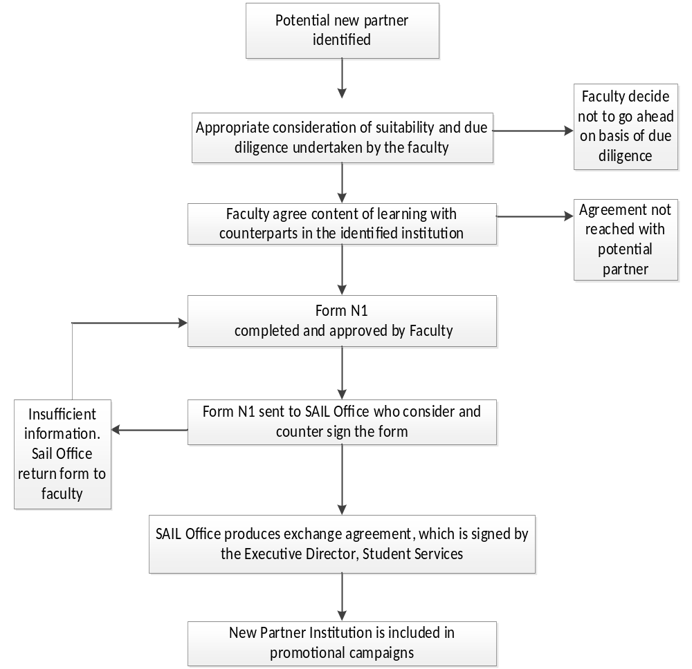

- This flowchart illustrates the process for establishing new exchange agreements.

- The process starts with the identification of a new partner. Due diligence on the suitability of the new partner is undertaken and approved at faculty level. Form N1 is completed and approved by the faculty. The form N1 is then sent to the SAIL Office who considers and counter signs the form. The Exchange Agreement is then produced by the SAIL Office, which is then signed by the Executive Director, Student Services.

Process

Proposing new agreements
- This section outlines the procedures for approval of a new exchange partner delivering credits that will be recognised towards Kingston University awards.

- Faculties, with the advice of the SAIL office where necessary, identify potential international exchange partners, using the criteria outlined in paragraph 14 as a guide, alongside appropriate consideration of the suitability of the curriculum offered by the partner.

- Once a faculty has identified a potential International exchange partner they complete form N1 (for Exchange agreements) and submit to the SAIL office. Faculties should undertake a proportionate level of due diligence at this stage and include the results of this on the completed form.

Due diligence for future agreements
- It is essential to have adequate due diligence processes to ensure that the potential host institution is a suitable exchange partner (see Section B of the Academic Quality and Standards Handbook). This includes having the appropriate academic credentials and Student Support Services for Kingston University’s outgoing students.

- Due diligence for exchange agreements should consider the potential new partner’s:
- reputation;
- vision/strategy;
- approaches to quality assurance;
- student support services (e.g. accommodation);
- suitability in terms of their curriculum and assessment strategies;
- language of tuition.

- Due diligence methods can include:
- a preliminary visit by Kingston University staff to the host institution;
- meetings between staff from Kingston University and the host institution;
- staff exchange prior to student exchange;
- consideration of marketing materials;
- consideration of annual reports and quality reports;
- reports from other HEIs.

- The approval of due diligence lies with the faculty before form N1 is submitted to the SAIL office. The signing of the form is a record that appropriate due diligence has taken place and has been approved. In addition to the proposer of this form, the signatures of the Exchange Coordinator and either the Head of School or the Dean (as per faculty policy), is required. This second signatory is the officer accountable for the signing off of due diligence.

- The SAIL office will only consider applications when all information requested has been received and this includes agreement from other faculties that may be delivering modules to incoming students on reciprocal agreements. The SAIL office will then prepare an exchange agreement for final sign off by the Executive Director, Student Services. Exchange agreements that are not signed by the Executive Director are invalid.

- For an exchange agreement, there is an expectation of reciprocity in the numbers of students exchanged. If there has been no activity after the first three years of the agreement, the SAIL office may elect to terminate the agreement.

- The SAIL office will provide support in sourcing partner institutional coordinator details. The authorised signatory for all exchange agreements is the Executive Director, Student Services and will only be signed on receipt of signatory request from the SAIL office.

Deadline
- The deadline for requesting a new Exchange Agreement is 30th of September in the year preceding the proposed first exchanges.

- The Kingston University policy for establishing, maintaining and cancelling agreements can be found on Staffspace.

Period of validity and termination
- All agreements will be reviewed on a three-year basis by the SAIL office in consultation with faculty exchange coordinators. Student feedback, levels of activity and ability to meet reciprocity expectations will be considered before an agreement is extended.

- For exchange partnerships, if there is consistently only incoming mobility, for subject-specific agreements, the faculty can decide to terminate the agreement, informing the SAIL office of the decision. Where decisions to terminate might impact on a student, for instance if they have been allocated for the following year, the student is informed and provided with the necessary and appropriate support by the faculty.

- For all partnerships, any agreements that are inactive for a period of three years may be cancelled by the SAIL office. The SAIL office will inform the partner institution of this decision and remove the partner from published lists.

Selecting and documenting outgoing students
- Outgoing mobility refers to a broad range of activities that involve students undertaking activities in another country funded through the Turing scheme. Most of these activities are reported to HESES through specific coding. For the purposes of the Academic Quality and Standards processes, the relevant broad categories are defined in the table below and refer to mobility that includes credit recognised against an award in years with normal activity.

 | Full Year | Teaching Block 1 | Teaching Block 2
Replacement year  (Only study abroad) | 120 credit module  or  two 60 credit modules at two different institutions | 60 credit module | 60 credit module
Additional year  (Study and/or work abroad) | 120 credit module  or  two 60 credit modules at two different institutions | 60 credit module or half year placement | 60 credit module orhalf year placement

- Students on a replacement year who study abroad for one teaching block only will undertake the remaining 60 credits at KU. This KU credit will be in the form of either complete modules (the short fat model) or partial modules (long thin model). In the former, students are assessed as required by the module assessment strategy and their results ratified at the MAB. The grades for this work will be used in the classification of the qualification. In the latter, students will be assessed either through relevant components of the overall module assessment strategy, or the programme team will devise bespoke assessment opportunities for such students that measure achievement on the parts of the module they have studied. The assessment will be graded, but the module grade will not be used in the classification.

- There are limitations to the opportunity defined as:
- students may go abroad for a minimum of two month placement / three month study, or a maximum of one academic year, subject to faculty approval;
- students on a three-year degree may only study abroad during year two;
- students on a four-year degree ‘with an industrial placement’ may only study abroad in year two;
- students on a four-year degree ‘with international exchange’ may only go abroad in year three, before returning to complete their final year at Kingston University;
- where students are replacing KU credits the learning agreement will cover either 60 or 120 credits, depending on whether they go for a single teaching block or a whole year;
- each faculty will publicise the offer for students according to the structure of the degree course.

- Information for outgoing students regarding tuition fees, funding, registration, grants and bursaries is available from the SAIL office.

Student application process
- Prospective students must apply online by the end of January of the year preceding the intended study exchange / work placement. The appropriate online form is available on MyKingston throughout the application period from 1 January.

- Faculties should ensure that the opportunity for mobility is widely promoted to students.

Selection criteria
- A student’s online application is considered by the relevant faculty, based on academic performance, attendance record and a personal statement submitted by the candidate. Faculties may include additional criteria, which are communicated to students before the application period.

- Faculties must have completed the consideration and approval of applications by mid-February. Following approval, the SAIL Office allocates each student to a destination in consultation with relevant faculty exchange coordinators, then sends a confirmed list to each faculty. When making allocations, preference will be given to the student's first choice.

- All students are informed by the SAIL office of their destination.

Learning and training agreements
- Once a student has been allocated a place, the student with the assistance of the faculty produces a learning or training agreement to cover the period of mobility.

- The learning or training agreement describes the nature and content of the programme of learning to be undertaken by a student during their period of study or work abroad. In the case of study abroad, it maps the relevant learning outcomes for the Kingston modules, with the modules they will take in the host institution, their credit values, and the equivalence to the KU modules they are replacing. The learning or training agreement forms the agreement between the student, Kingston University and the host institution. It can be re-negotiated if necessary at any stage.

- For students going abroad for a single teaching block and on KU modules that span the whole year, the learning agreement must include any additional assessment that the student will be required to complete in order to demonstrate attainment of the broad learning outcomes for the whole year. In effect the learning agreement must underpin the entire year’s learning experience.

- Learning and training agreement templates are sent to selected candidates by the SAIL office. The agreed learning agreement is then signed by the student, the faculty and the host institution. It is the student’s responsibility to obtain the signature from the host institution.

- A compulsory pre-departure meeting explains all conditions of the exchange.

Rights and duties
- KU students participating in an exchange programme abroad are subject to the same rights and duties as all other KU students. This includes access to the university complaints and appeals procedures.

Insurance
- KU students are covered by the Kingston University Travel Insurance Policy whilst participating in a faculty-approved activity abroad.

- KU students are responsible for meeting any additional insurance requirements of the host university, or for ensuring they are covered by their employer's liability insurance.

Credits abroad and transcripts
- Students must complete a minimum workload abroad, as set out by the faculty. Credits taken abroad will not apply towards the final degree classification. A student may receive a maximum of 120 Kingston University credits (60 ECTS) for a year abroad or 60 Kingston University credits (30 ECTS) for a teaching block abroad.

Recognition and grade transfer
- Upon completion of an exchange period Kingston University students will be issued a transcript by the host university. In all cases, the original transcript for a student is forwarded to the faculty, while a copy is kept by the SAIL Office. Once the document has been used for recognition of studies purposes, the original is available for the student.

- The faculty will transfer the credits earned abroad to SITS and evaluate whether the student has met the minimum criteria for academic progression. This decision will be sent to the assessment board for ratification. Grades achieved abroad will not be converted into KU grades. All study abroad or work credit is recorded as pass only and does not count towards classification.

- Modules taken abroad and recognised by Kingston University will be included on the Record of Progress and the HEAR, indicating the country, the partner institution where they were taken and the discipline.

- Students allowed to go abroad for a single teaching block and who are registered on a year-long module will require an alternative assessment approved by the relevant faculty.

Incoming Students
- Incoming students’ study at Kingston University through an Erasmus Bilateral Agreement, a Memorandum of Understanding, or an individual contract with their home institution. Some incoming students (mainly from non-European partners) may be on programmes at their home institution which necessitates studying modules in more than one department/faculty at Kingston University, to ensure that the aims and objectives of their learning contracts are attainable. It is important therefore that faculties consider the possibility of cross faculty delivery to incoming students when developing exchange agreements and secure the necessary agreement from those other faculties. The table below shows the schedule for preparing for incoming students:

Timescale | Action | Responsibility
March | Faculties inform the SAIL office of the modules that will be available for incoming students for the next academic year. | School/ Faculty/ Exchange Coordinator
March/April | The SAIL office publishes the list of modules available on the website and potential candidates start their selection of modules. | SAIL office  Incoming students
By 31st May (Sept start) or by 1st Nov (Jan start) | The SAIL office receives a list of the selected incoming students from the partner institutions. | Partner institutions
July/ Sept (Sept Start) or Dec (Jan Start) | Learning contracts agreed and signed for Exchange students. | School/ Faculty/ Exchange Coordinator
Aug (Sept start) or Dec (Jan start) | Schools/Faculties receive a list of the names of incoming students, what they are going to study and for how long. | SAIL office/  Faculty (for Erasmus students)
Once a student has completed their agreed assessments. | Students assessed appropriately against their learning agreement. | School
Within 30 days of student completing their studies at KU. | Complete Certificate of Attendance (COA) for each student for Erasmus students. | School/ Faculty/ Exchange Coordinator
Once a student has completed their studies at KU. | Provide each student with a transcript of their studies at KU. | Europe: School/ Faculty/ Mobility Coordinator  Non-EU: SAIL Office

Oversight and Review
- Faculty Management Groups (FMG) are responsible for maintaining oversight of exchange agreements operating from their respective faculties.

- A review meeting, involving the SAIL office, Academic Registry and faculty based staff with responsibility for student exchanges will be held annually. The purpose of the meeting is to review the operation of the study abroad arrangements, to consider any agreements for closure and to make recommendations for modifications or improvements to process. The outcomes of this meeting will be reported to the Education Committee (EC).

Appendix A

Policy owner | Head of QAE
Policy department owner | QAE
Committee responsible for review and approval | Education Committee
Version number | 1.0 - 2026-27
Last updated | June 2026

