

Annual Monitoring and Enhancement (AME)
Course Enhancement Plan (CEP)
User Guide 2026/27

Contents
Kingston Continuous Enhancement Process (KCEP): An Introduction 3
The Course Enhancement Plan (CEP) 3
Business Intelligence (BI) 4
Getting Started 5
Finding your Course Enhancement Plan (CEP) 8
Data in the pre-populated CEP form 13
Decimal points and rounding 14
KPI Benchmarking 14
Completing your CEP Form 15
Section 1: Action Plan 17
Sections 2 – 7 20
Section 8: Themed Question 22
Section 9: Good Practice 22
Section 10: Actions arising from External Examiner Reports 22
Oversight of Course Enhancement Plans 23
Sources of Help 24
Annex 1: Course Group Aggregation Model 26

Annual Monitoring and Enhancement (AME): An Introduction
The Annual Monitoring and Enhancement Process provides an opportunity for review, reflection, and evaluation of the delivery of modules and courses and for identifying issues, risks and actions for improvement and enhancement. It also provides an opportunity for identifying and celebrating success, promoting best practice, and learning from each other. Full detailed information can be found in Section D of the Academic Quality and Standards Handbook (AQSH).

A separate annual monitoring and enhancement process has been developed for provision delivered with collaborative partners. Please see Section B of the AQSH for more information.

The Course Enhancement Plan (CEP)
The Course Enhancement Plan provides the opportunity for the Course Leader in conjunction with the course team to evaluate the performance of the course. Your evaluations should consider student performance on the course, student views, external examiner comments and your own observations (and those of the course team), which may lead to action either to enhance provision or to address problems that have been identified.

The review of the CEP should ensure that:
- The course curriculum continues to be relevant and up to date.
- The teaching, learning and assessment approach for the course continues to be effective.
- There are formal opportunities for reflection and evaluation, informed by analysis of performance of the course against the Key Performance Indicators (KPIs) and an analysis of the Key Monitoring Information (KMI), which may lead to further enhancement.
- There is formal consideration of student feedback (including, but not limited to, the outcomes from the NSS and PTES)
- Feedback from the teaching team, external examiners and students receive a prompt response.
- Any specific risks or issues associated with the course are identified and an appropriate action plan is put in place.
- For Apprenticeship courses, any actions arising from the Apprenticeship Monitoring Committee (AMC) are included in the CEP.

Business Intelligence (BI)
A dedicated site in SharePoint was developed to facilitate the provision of pre-populated Course Enhancement Plans (CEPs) which draw on data from SITs and other external sources that is stored in a data warehouse. This data, when combined with the range of qualitative data which forms the Key Monitoring Information set, provides you with the starting point to reflect on the performance of the course.

The system operates at Course Group Level which is driven by the University’s Course Group Aggregation model. This will make possible the production of a combined CEP for all cognate courses in a cluster e.g., FT, PT, with Professional Placement, etc.
It is the expectation that CEPs should run at the Course Group level. Filters in the dashboard will allow the analysis of the individual courses within a course group if wished.

Getting Started
The site in SharePoint is accessible to all staff with a KU ID. Staff from partner institutions, who have a KP account, are also able to access the site by following the link here.

There is no need to log in with a dedicated username as your KU account will be automatically recognised. (You can save this link in your favourites by clicking on the star on the tool bar on top right-hand corner of the screen and click ‘Add to Favourites’).
Alternatively, KU staff can access the site via Staff Space by choosing the drop-down menu under the Resources tab and then selecting Annual Monitoring and Enhancement.
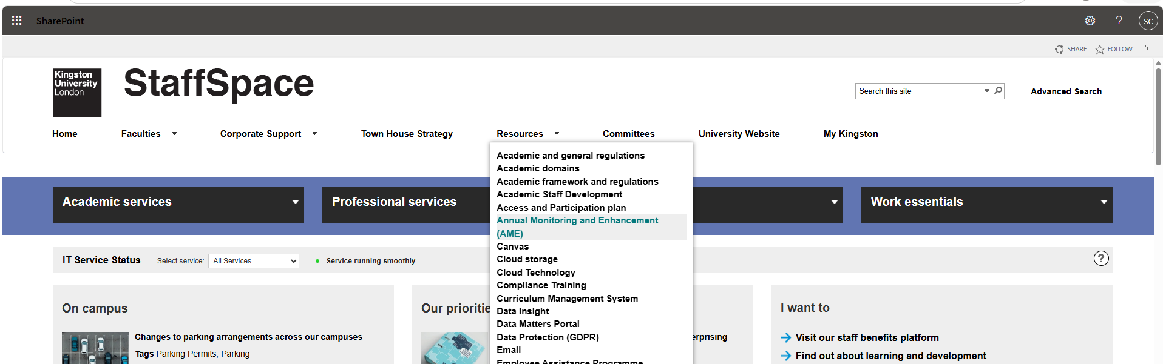

This displays a new screen which allows you to choose the CEP tile, OR review CEPs from previous years.
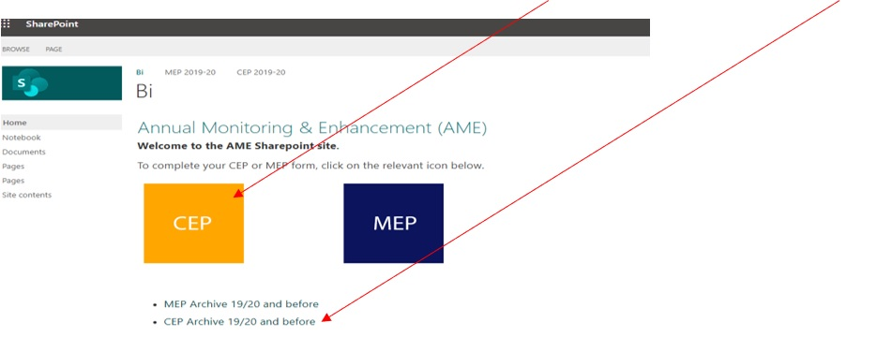

On the next screen, you will need to select the CEP tile.

If a message is displayed advising that you are using an old version of the app and to refresh to use the latest version, please do refresh by selecting ‘refresh.’

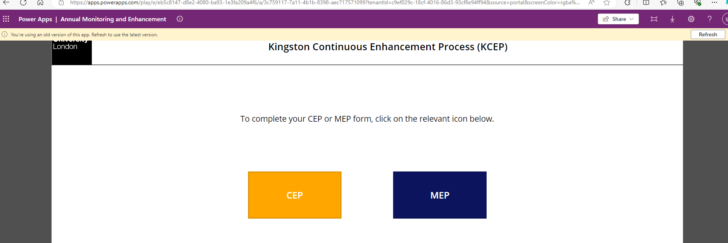

Finding your Course Enhancement Plan (CEP)
If you select the CEP tile the following new window containing a series of filters will be displayed.
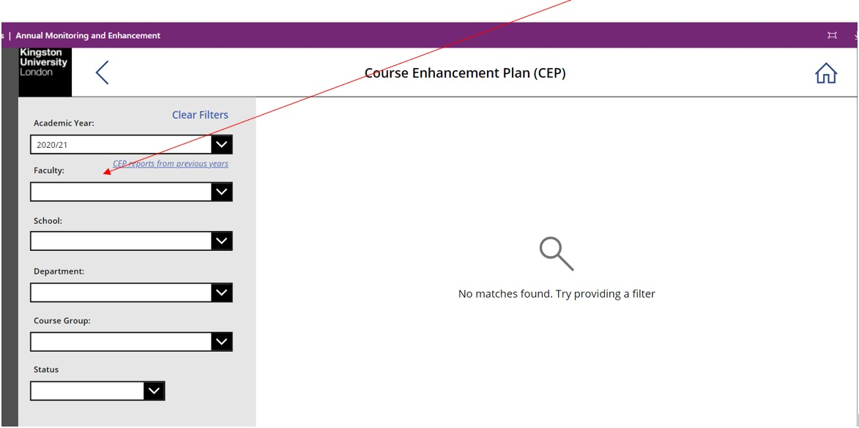

You should select the correct year from the academic year drop-down menu. If you are completing your CEP in August/September 2026 you should select the 2025/26 academic year. CEPs from previous years are also available in case you need to access a CEP that has been completed previously.

Click the drop-down arrows at the right of each filter field to then select your Faculty, School, Department and Course Group.

What level of report should I run?
You will notice different “levels” of templates. In most cases the recommended CEP to complete is the one at Course Group level on the very top line. This has a blue square icon next to it and starts with “G.”
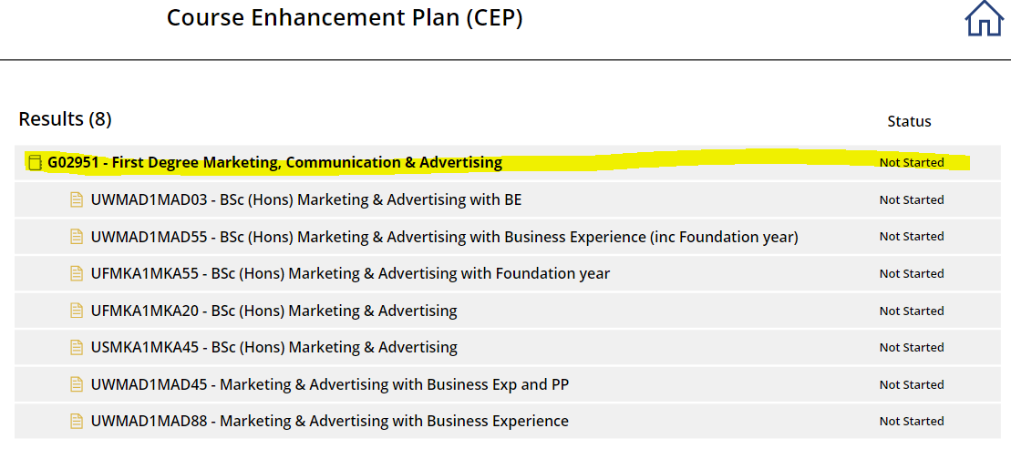
The course group CEP takes the data from all permutations of a course (i.e. FT, PT, with Professional Placement, Jan/ Sep intake) and amalgamates it into one comprehensive CEP, reducing the need to run individual reports for each individual entity of a course.

The Course Group Aggregation model has been devised by the Planning Office and groups like courses together. Each cluster of courses has been allocated a unique Course Group code that is held in SITS. There has been extensive consultation with faculties on this coding convention for the Course Group Aggregation and the individual allocation of courses to groups (See Annex 1 for further detail).

Selecting a CEP for an individual location or different modes
The University operates courses that are franchised to partner organisations e.g., the Foundation Degree in Early Years. The CEP is displayed at the Course Group level (which will aggregate all partners into one report) or for each individual provider of a course.

If a course has a different provider, the CEP should be completed at Course level to differentiate between KU delivery and individual partner delivery. Course level is indicated by a yellow document symbol. A separate annual monitoring process applies for collaborative provision and, therefore, the CEP should not be completed for courses delivered at collaborative partners. Please see section B of the AQSH for more information.
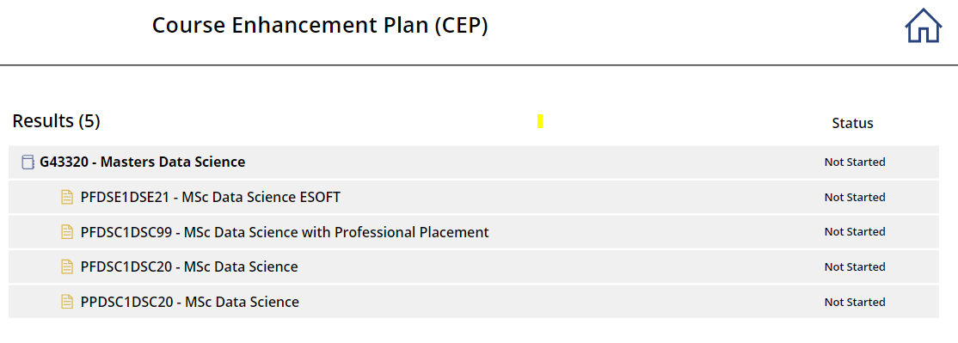
Foundation Years
Where a course has an associated Foundation Year the level 3 element of these courses are grouped under the Course Group level of the associated programme under the pseudonym ‘Foundation Year’ which can be selected under the drop down for School and Department.
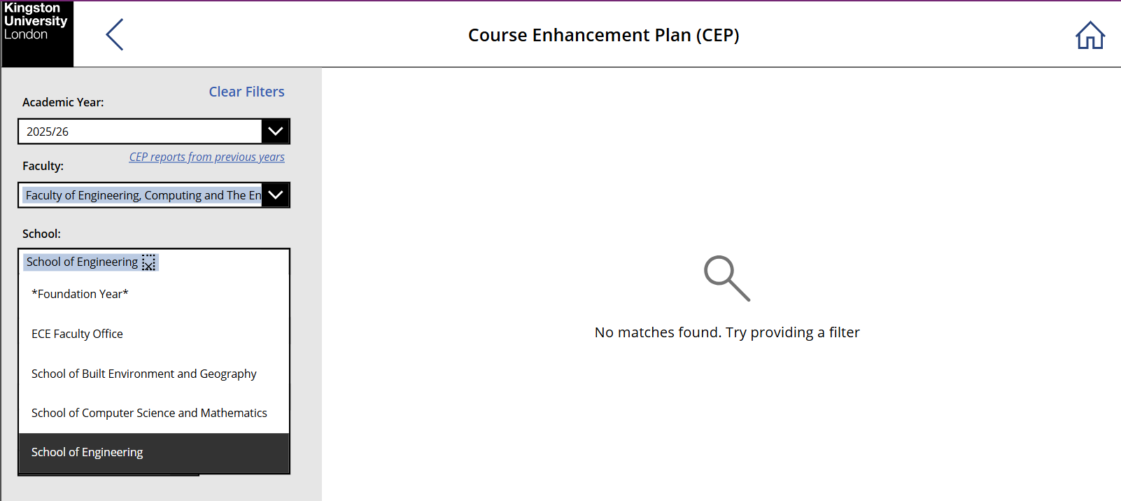

In order to group provision of Foundation Year courses without disturbing the main aggregation, a Level 3 subgroup is applicable where courses have activity at Level 3. This ensures students who progress to Levels 4+ are still counted in the main aggregation but the level 3 element of any course can be isolated and reported on separately. It is not possible to combine the data for all four years of an integrated degree.

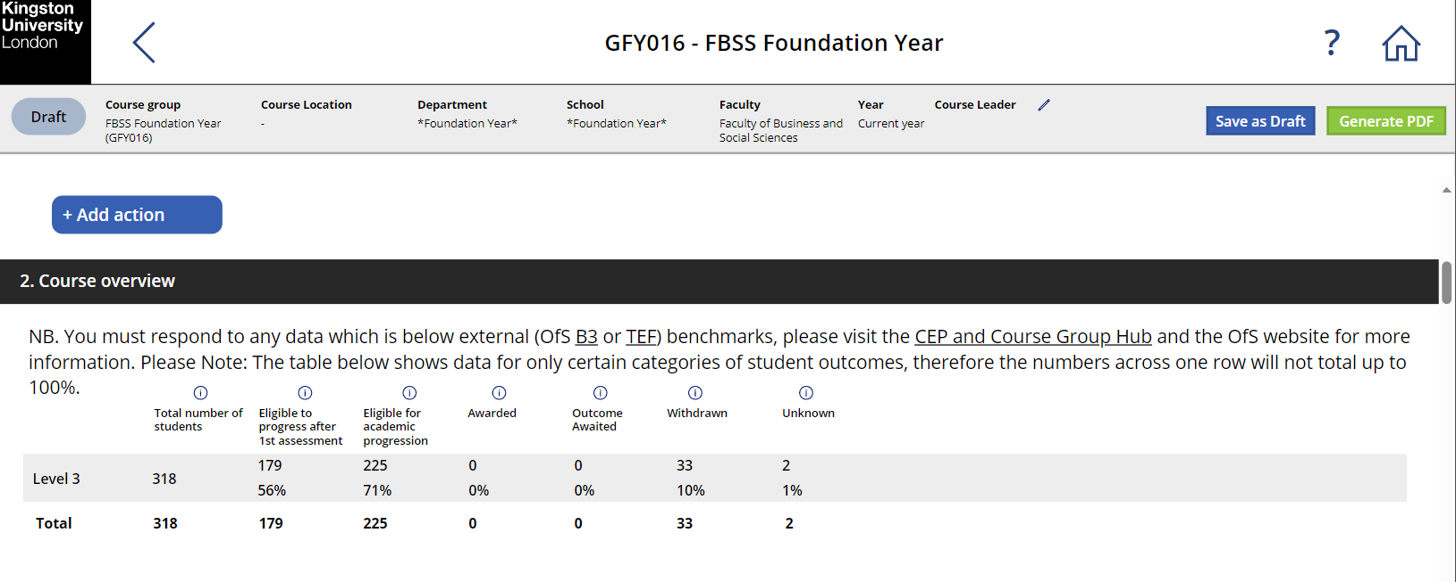

If you are unsure of which CEP to complete, then please contact your QAE team.

Data in the pre-populated CEP form
Sections 2 and 3 of the template include data drawn from a variety of sources (e.g. SITS). Some of the data is drawn from static data tables (NSS, Graduate Outcomes, tariff, and retention) that have been developed by the Planning Office. This data will be updated once each academic year.

The course performance data is fed from a live link from SITS to the data-warehouse and will change depending on the time of year the report is viewed. This data will continue to be refreshed and each time you visit your report the data will be as at the current date, until the CEP is in ‘final’ status.

Depending on your course, there will be elements of the course performance table that are not applicable to your course – i.e., a UG course that does not include a Foundation Year element. Where this is the case, the field will be populated with a 0 and the corresponding percentage box will state N/A. If 0 is a genuine value – the field will be populated, as will the % field.

At all levels the percentages across all the columns may add up to more than 100%. This is due to column criteria not being mutually exclusive.

Decimal points and rounding
All figures are shown to two decimal points. This is particularly the case where students on combined honours programmes are apportioned to two subject areas – i.e., a student doing a major/minor combination in Creative Writing and History will be apportioned 0.77 of an FTE to Creative Writing and 0.33 of an FTE to History. This explains why in some instances the data will present fractional numbers – no rounding has been applied to the figures.

KPI Benchmarking
The KPI data has been benchmarked against the University agreed KPIs (see Guidance DG(i) for more information). If the KPI in question has been breached, there is an expectation that this is addressed in the Action Plan.

Completing your CEP
This section of the User Guide provides advice and guidance on completing the CEP. The guidance does not constitute a check list but is provided to guide thinking and reflection of the sorts of issues to consider.

IMPORTANT - your CEP will NOT autosave. Therefore, whilst writing your CEP, please ensure you periodically save your work in draft by selecting the Save as Draft button at the top right-hand side of the screen.

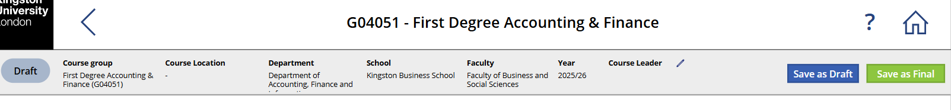

It is not necessary to complete all sections of the CEP at once, but you can return to the CEP to amend or finalise sections as required.

Generating a PDF
You do not need to complete all sections of the CEP to generate a PDF. The only mandatory part of the CEP is the ‘course leader’ field. Therefore, you can update a specific section of the CEP and then select the Save as Final’ button which will change the status of the CEP and will generate the PDF. This will allow you to keep an audit trail to track any updates. You can then revert back to draft to continue updating the CEP.


To view previously generated PDFs, select the file icon.

Section 1: Previous Year’s Action Plan
You are asked to consider each of the actions identified in last year’s report in turn, identifying for each:
- Completed actions – include a short description that reflects on relative progress or success of the action taken
- Incomplete actions – please identify whether these continue to be ‘live’ actions – if so, please ensure that they are included in the new action plan

EXAMPLE
Action 1 - The course team will include greater employer input to the course - with the aim of enriching the curriculum through the contribution of guest lecturers on specific industry-based topics, the introduction of real-life case studies and the participation of employers in the dragon’s den style event scheduled for TB2.
This action has been successfully completed. The team were able to secure the input of renowned industry guest lectures on five occasions – feedback from students suggest that they found these sessions insightful and relevant to the delivery of the module. The introduction of the real-life case studies to the group-work element of assessment was successfully implemented in TB2, students responded well to the challenge associated with these real live case studies and particularly welcomed the mentor support that was available to each group from alumni and the case-study authors. The marks for students on this element of assessment were consistently in the 2:1 range with no failures – this was a considerable improvement on the previous year. The dragon’s den activity took place as scheduled, but we were unable to secure employer participation. The exercise is a useful addition to the learning and teaching strategy and will continue a feature. The team will plan employer participation at an earlier point next year.

Sections 2 and 3
Sections 2-3 of the CEP contain pre-populated data as follows:
- Course overview
- Student attendance and engagement
- Award data and Value Added
- National Student Survey (NSS) (UG only)
- Postgraduate Taught Experience Survey (PTES) (PG only)
- Aggregated Course Level Module Evaluation Questionnaires (MEQs)

As well as the pre-populated data, it is important that you make use of the relevant CEP Hub which brings together key metrics to support a holistic overview of the course performance throughout the student journey.
- UG CEP Hub
- PGT CEP Hub

You will also need to use the relevant dashboard to access Career Registration data which is not pre-populated in the CEP - Dashboard

You should critically reflect on the performance of the course and, for each data set, think about:
- What went well, and why?
- What went less well, and why?
- Are there particular factors that impacted on the course, student performance or the student learning experience?
- What (if any) action needs to be taken?

The following is not a checklist – but you may wish to consider these prompts to guide your thinking:
Student Recruitment | Assessment
- The achievement/challenge of meeting recruitment targets  - Tariff score for UG provision  - Effectiveness of welcome and induction | - Balance and variety of assessment methods used  - The reliability of assessing learning outcomes  - Turnaround times  - The effectiveness of systems for internal moderation  - The effectiveness of the arrangements for making sure students receive feedback and feed-forward on summative and formative assessment  - The views of external examiners on …. what?
Learning & Teaching | Student outcomes
- The effectiveness of learning and teaching methods  - The fitness for purpose of on-line materials  - Measures to ensure that the curriculum is inclusive | - Academic progression rates from year 1  - Reassessment rates  - Performance of students in different types of assessment  - Proportion of good honours degrees/merits/distinctions awarded  - Effectiveness of measures to reduce the attainment gap
Personal Tutor Scheme | NSS
- The effectiveness of the personal tutor scheme | - An analysis of the current NSS results and how they compare with previous years  - An indication of whether actions taken in the past have had a bearing on the most recent results  - Whether recent changes (e.g., increases in student numbers or changes to the curriculum) have had a bearing on the results
Resources | Progression to Graduate Outcomes
- Change in the resource base for the course (including the departure of key staff and new arrivals)  - Staff development issues and priorities  - Adequacy of access to learning resources (teaching accommodation including specialist accommodation, hardware, software, library resources, specialist equipment)  - Access to placements (where relevant)  - Staff achievements (KAPS/PhD) | - Analysis of the most recent Graduate Outcomes Survey results  - Curricula and extra-curricular activities to enhance the employability of graduates
Quality Assurance | Professional, Statutory & Regulatory Bodies (PSRBs)
- Update on action plans from Substantive Reviews | - Any new or anticipatory changes from the PSRB  - Continued compliance with the expectations of PSRBs

Section 4: Curriculum Updates
Section 4 contains a themed question relating to curriculum updates that you are asked to respond to.

Section 5: Good Practice
This section of the CEP is the opportunity to reflect on those aspects of the delivery of the course or the student experience that have been particularly positive or successful. This might be new or innovative practice, things that students have responded particularly well to, or the consequences of actions you have taken to deal with a particular problem or issue that have been particularly effective.
It is anticipated that others could learn from, or adapt for their own use, positive features identified in this section of the CEP. If you have undertaken formal evaluation of these positive aspects, please include references. It is not a requirement that there has been extensive formal evaluation of the things identified in this section – however if you have evidence of some form of evaluation e.g., peer review or student feedback, whether formal or informal please cite.

Section 6: Action Plan
An action plan in response to data and evidence relating to student experience and outcomes (at both overall and splits levels) should be developed. This includes (and is not restricted to): NSS, PTES, MEQs, Student Forum feedback, continuation, and completion (including internal indicators such as pass at first attempt and retention), Graduate Outcomes, student engagement or attendance rates, external examiner feedback, PSRB requirements, student numbers and observations by the course team.

Actions should be supported with appropriate data analysis in the relevant section to provide a rationale for the action.

Please note that any actions identified which change the information contained within the module descriptor or programme specification must be approved through the Course Modification Process (CMP) (see section G of the AQSH).

The actions that you identify should be SMART (specific, measurable, achievable, relevant, and timely). The CEP template guides you to produce this by asking that you:
- describe the issue
- evidence it
- detail action/s you plan to take
- assign responsibility for the action
- set a deadline for the action

Oversight of Course Enhancement Plans
Faculty Course Review Summits will be scheduled to take place in September each year. CEPs should be reviewed in advance of these Summits and attendees will have the opportunity to review and refine their CEPs at the events.
Heads of School are required to submit a report to their Faculty Education Committee (FEC) using template D4. Drawing on the reports from Department Module Review Forums and discussions at School Education Committees and Faculty Course Review Summits, Heads of School will be asked to:
- confirm that MEPs/CEPs have been completed
- identify areas of good practice
- identify issues to escalate to the Faculty/University
- confirm that modules and courses being delivered in the school are maintaining the standards required of KU awards and providing a high-quality student experience.

Each FEC will receive the relevant Head of School reports and will be asked to:
- confirm that MEPs/CEPs have been completed
- identify good practice
- identify issues to escalate to the University
- confirm that all courses have been appropriately reviewed to the level of completeness and standard required
- confirm that modules and courses being delivered in the faculty are maintaining the standards required of KU awards and are providing a high-quality student experience
The above detail should be recorded in the minutes, which will then be used by QAE to draft the annual AME report for submission to the University Education Committee.
.

Sources of Help
There is a wealth of information on the Canvas ‘Support for Academic Staff’ module which includes:
- FAQs regarding CEPs
- Video recording of AME briefing session

Sources of further information to inform your CEP:
- Data dashboards - All dashboards can be accessed here: https://datainsight.kingston.ac.uk/#/home
- Data Insight and Analysis - Data Insight Support (sharepoint.com)
- Access, Participation, and Inclusion - Access, Participation & Inclusion (sharepoint.com)
- Student Voice- Student Voice (sharepoint.com)
- Graduate Outcomes, Employability - Careers and Employability (sharepoint.com)
- Student Recruitment/ Admissions - Marketing and Communications (sharepoint.com)

Help for IT specific queries via the IT Service Desk:
- Monday to Friday 8am to 6:30pm
- Internal Ext: 63355
- External +44(0)20 84173355
- Email ITS - Home / Service Desk Portal (kingston.ac.uk)

If your query remains unanswered, please contact the QAE Team at qae@kingston.ac.uk

Annex 1: Course Group Aggregation Model
Following feedback, the Course Group Code has evolved into the six-digit code below - please read the attached cell comments for each section.
Course Aggregation Model (CAM) - Version 9.2.2
GENERIC PREFIX | SUBJECT CODE (3 digits) | AWARD TYPE | INCREMENTER
G | 0 1 0 | 2 | 0
Note: GAAAAA and GBBBBB refers to KSA & FBSS joint courses where the aggregation must be undertaken by using the individual JACS components as depicted in the SITS PSD (Pathway Subject Department) screen.

Subgroup: Foundation Year Courses at Level 3
In order to group provision of Foundation Year courses without disturbing the main aggregation, a Level 3 subgroup is applicable where courses have activity at Level 3. This ensures students who progress to Levels 4+ are still counted in the main aggregation, but Level 3 activity for these courses can be monitored separately. The groups are detailed in the sheet "Level3 Subgroups".

Guidance owner | Head of QAE
Guidance department owner | QAE
Committee responsible for review and approval | Education Committee
Version number | 1.0 - 2026-27
Last updated | June 2026

