Annex C:

Process for the Validation of a New Collaborative Partner Course

The following flowchart illustrates the series of events relating to the approval of a new course that will be delivered by a collaborative partner institution.

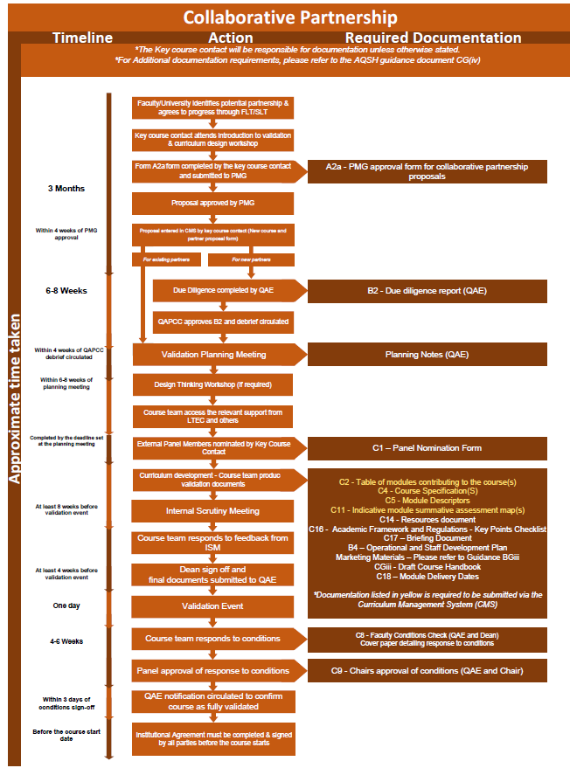

Appendix A – Document Information

Document owner | Head of QAE
Document department owner | QAE
Committee responsible for review and approval | Education Committee
Version number | 1.0 - 2026-27
Last updated | October 2026

