Annex D:

Process for the Curriculum Review of Existing Courses

The following flowchart illustrates the series of events relating to the process of approving a Curriculum Review of an existing course.

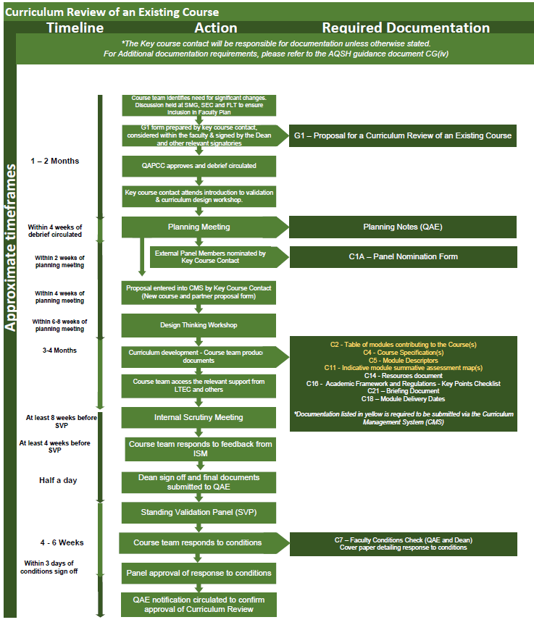

Appendix A – Document Information

Document owner | Head of QAE
Document department owner | QAE
Committee responsible for review and approval | Education Committee
Version number | 1.0 - 2026-27
Last updated | October 2026

