Annex A:
Post PMG Processes for New Courses Following Approval to Proceed to Validation

The following flowchart illustrates the post-Portfolio Management Group (PMG) activities following the approval of a proposal to proceed to validation and the validation of a new course.

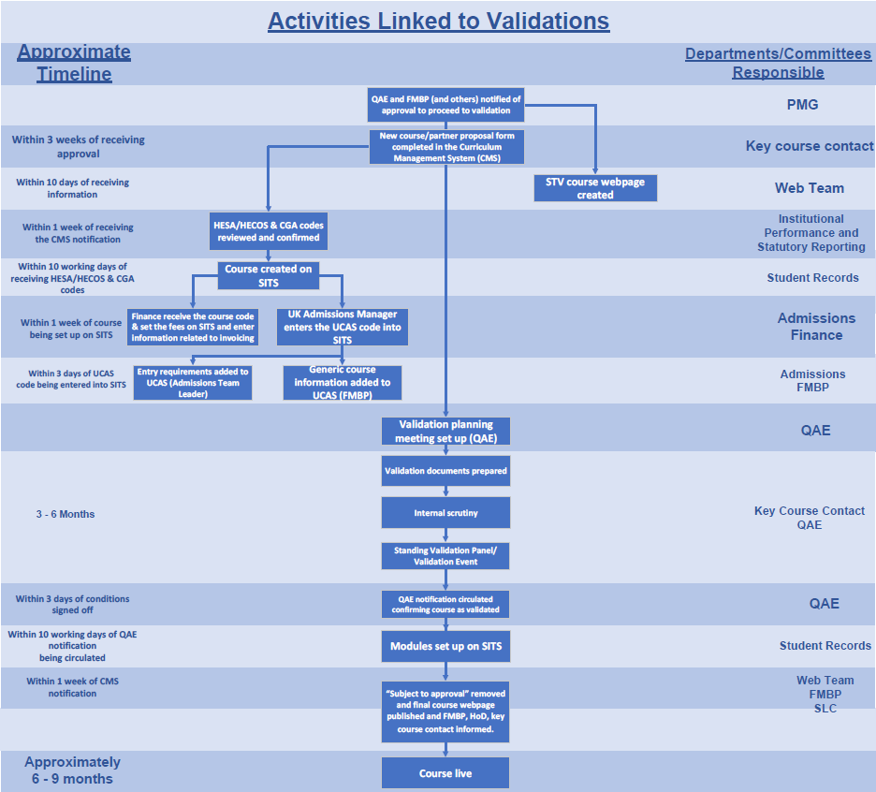

Appendix A – Document Information

Document owner | Head of QAE
Document department owner | QAE
Committee responsible for review and approval | Education Committee
Version number | 1.0 - 2026-27
Last updated | October 2026

