

Kingston Continuous Enhancement Process (KCEP)

Module Enhancement Plan (MEP)

User Guide 2025/26

Contents
Business Intelligence (BI) 3
Pre-populated data in the MEP 3
Module Occurrences 4
Getting Started 4
Finding your MEP 6
Completing your MEP – things to consider and saving in Draft. 10
Submitting your MEP 14
Sources of Help 15
Annex A Technical Specification 17
Annex B Data Explanation 20

Business Intelligence (BI)
A dedicated Continuous Monitoring and Enhancement (CME) site in SharePoint has been created. This provides pre-populated Module Enhancement Plans (MEPs) and Course Enhancement Plans (CEPs) which draw on data from SITs and other external sources stored in a data warehouse. This data, when combined with the range of qualitative data which forms the Key Monitoring Information set, provides module teams with a starting point to reflect on the performance of their module.
More information about the Kingston Continuous Enhancement Process and the processes associated with the MEP can be found in Section D of the Academic Quality and Standards Handbook (AQSH).

Pre-populated data in the MEP
Section 3 of the template includes data drawn from SITS and specifically the data presented to the Programme Assessment Board (PAB). The Module performance data is fed from a live link from SITS to the data-warehouse and is updated daily. This means for example if you were to run your report in January no module data will be available. If you run your report prior to the PAB this will display actual marks, as opposed to agreed marks and could therefore be subject to change by the PAB. If you run your report after the PAB, your MEP will contain agreed marks. Annex A is the technical specification for these calculations. Annex B provides a basic explanation of how the data is calculated.

Module Occurrences
Functionality has been built into the MEP tool to enable you to run reports for individual occurrences of a module. Where modules have more than one occurrence, faculties should produce a MEP for each occurrence so that performance across occurrences can be compared if necessary.

Getting Started
The CME site in SharePoint is accessible to all staff with a KU ID number. Staff from partner institutions, who have a KP account, can also access the site either by following this link StaffSpace or copying the URL into the address bar.
Once in StaffSpace, choose the drop-down menu under the Resources tab and then select Kingston Continuous Enhancement Process (KCEP).
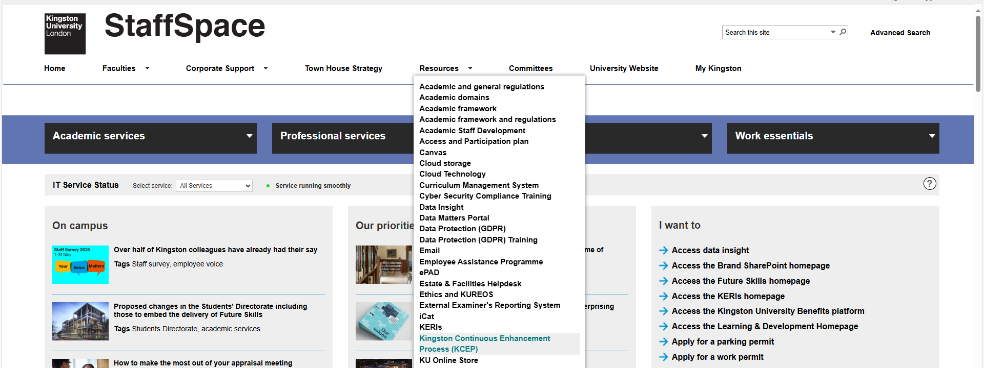
This displays a new screen which allows you to choose the MEP tile, OR you can review MEPs from previous years.
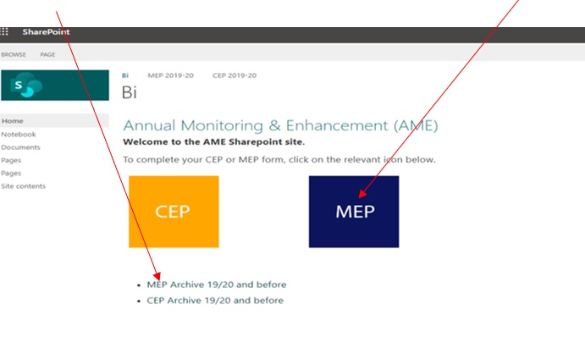

Finding your MEP
There are 2 ways to find your MEP, via the module code or the subject area:
TO FIND A MEP USING THE MODULE CODE, enter the code in the module code area below.
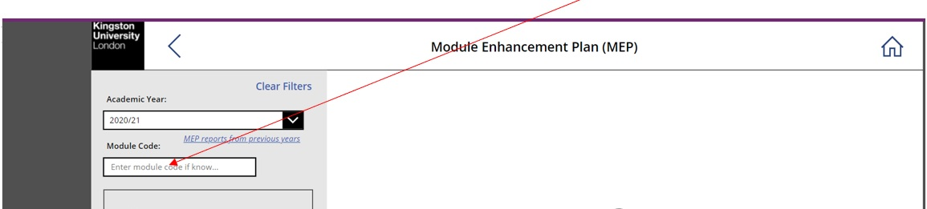
…and press ENTER. This will display the module.

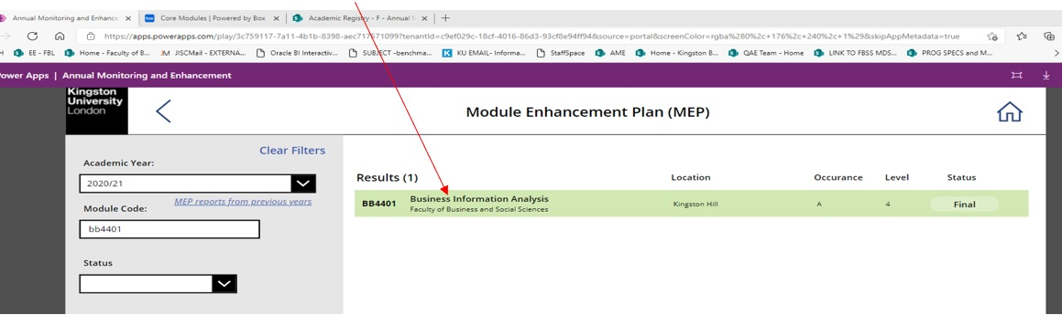
Always make sure you are selecting the correct module – this is particularly important when retrieving a partially completed or final version of a report!
TO FIND A MEP USING THE SUBJECT AREA, click on the drop-down list titled Subject Area (shown below)
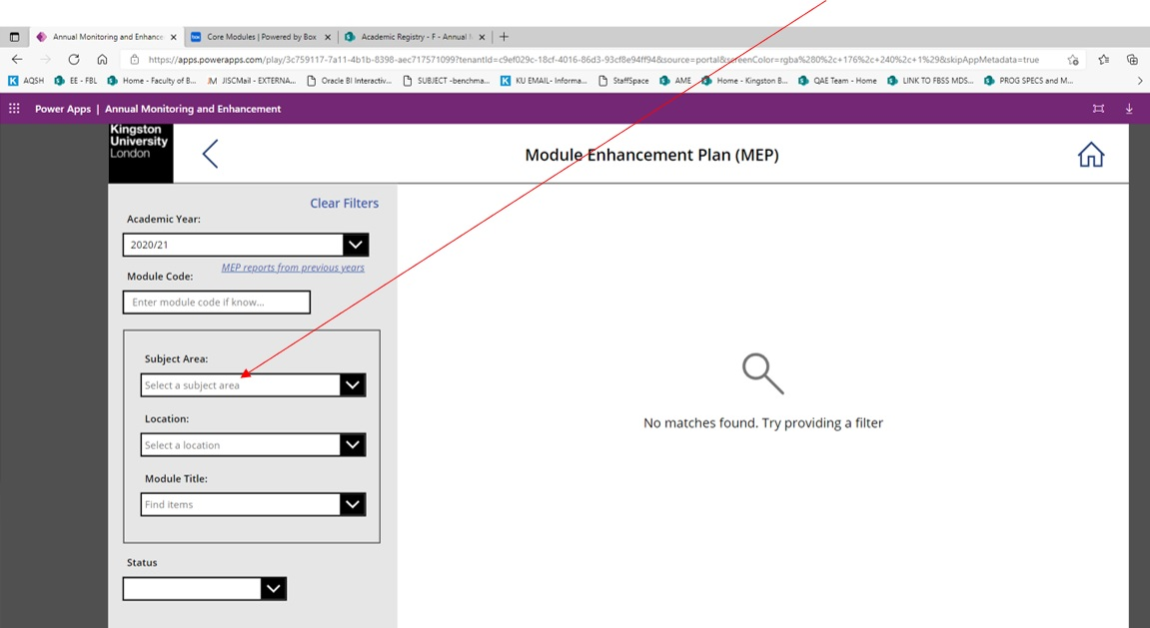

This will display all modules relating to the same subject:
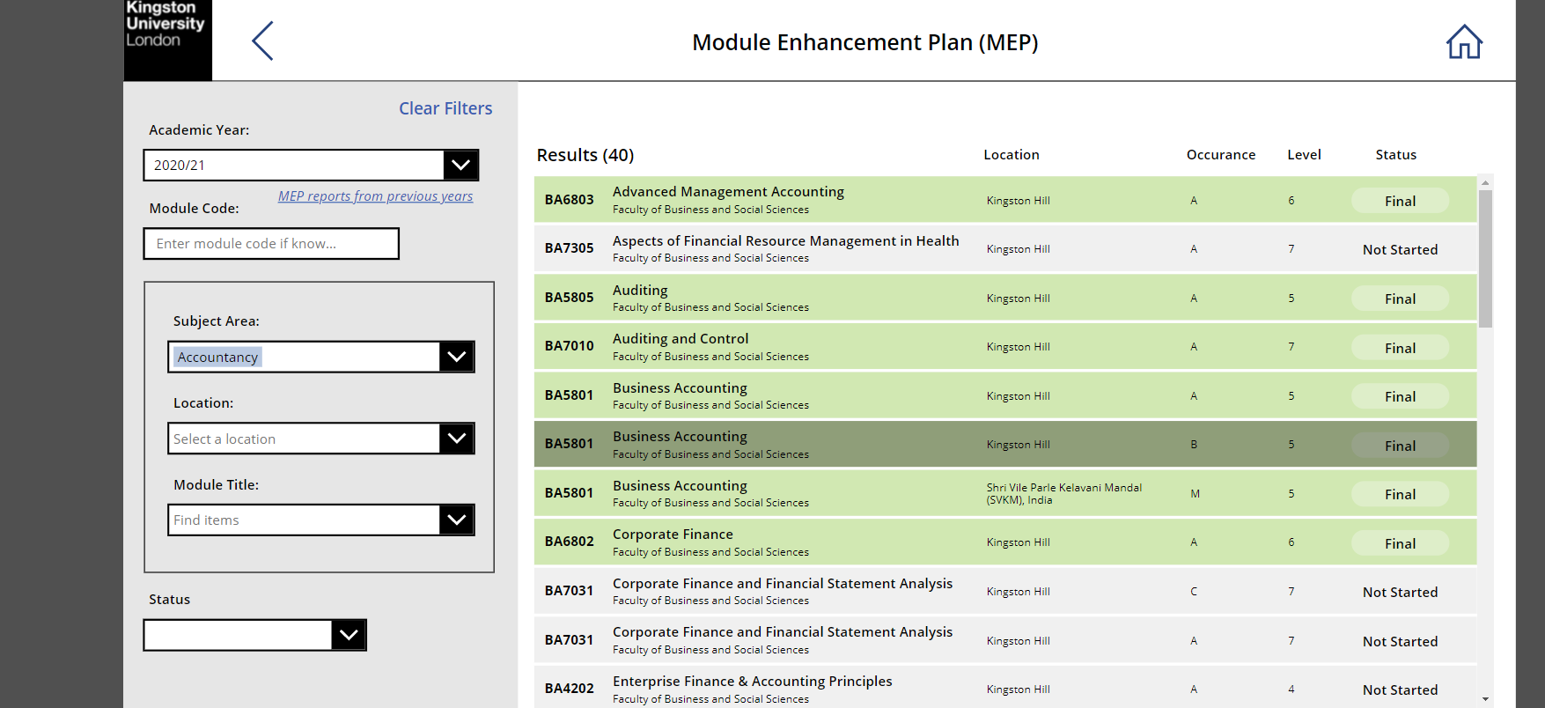
You will notice in the example above that some modules are repeated (for example BA5801). This is because this module has multiple occurrences, which in this instance are delivered via partner institutions (identifiable from the location name column). Occurrences A and B are cohorts belonging to 2 different programmes but who study the same module. However, occurrence M is taught at a partner in Mumbai. If you are unsure what the occurrence relates to, please check with your course and student administration team in the first instance.

Completing your MEP – things to consider and saving in Draft.
This section provides guidance and examples of the sorts of issues to consider when completing the MEP. The guidance does not constitute a check list and is provided to guide reflection of the sorts of issues to consider.
Your MEP will NOT save automatically. Therefore, whilst writing your MEP, please ensure you periodically save your work in draft by selecting the Save as Draft button at the top right of the screen. If you must leave your MEP before you have finished – always remember to Save as Draft.
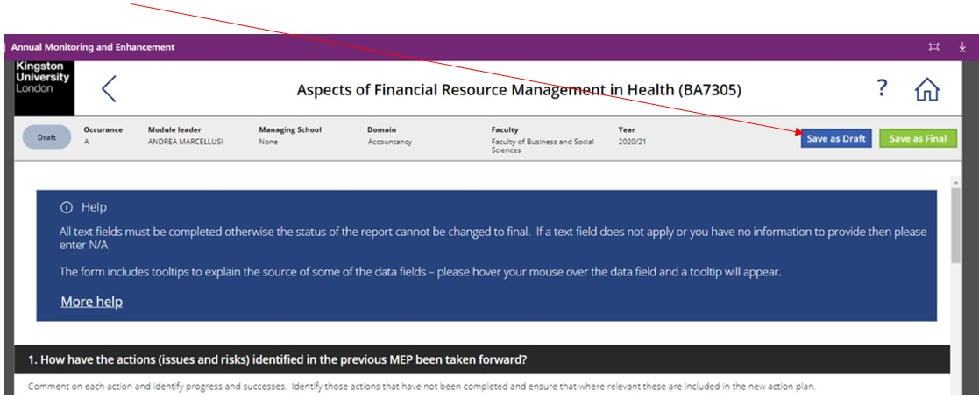
To support you in completing your MEP, a dedicated MEP and Module Hub has been created. This brings together all of the data that you must use into one place. This dashboard can be accessed here
Section 1 – Other Sources of evidence used.
Tick the relevant boxes. If you have used additional evidence, please indicate in the free text box.

Section 2 - How have the actions identified in the previous year’s MEP Action Plan been taken forward?
When responding to this question you are asked to consider each action identified in last year’s report in turn, identifying for each:
- Those actions that are complete – include a short reflection on the progress, success (or lack of success - if appropriate) of the action taken and any learning points.
- Those that are incomplete – please identify whether these continue to be ‘live’ actions and if so, please ensure they are included in the new action plan.

Section 3 – Performance of the module
This section provides an opportunity for the module leader to critically reflect on the performance of the module during the preceding academic year in terms of performance against the KPIs and the other Key Monitoring Information (MEQ, EE reports, SVC minutes etc.)
Section 4 – Student Voice
This section provides data on the MEQ response rate and overall satisfaction rates for each theme within the questionnaire.
When completing this section, module leaders should make use of the data available in the MEP and module Hub to investigate the outcomes for specific groups of students.
Data for previous years is also included to allow module leaders to see trends. In this section module leaders are asked to provide a commentary if the MEQ response rate is below 50% and if the satisfaction rate for any theme is below 80%
Section 5 – Commentary on the performance of the module during this reporting year
This section provides an opportunity for the module leader to reflect on the performance of the module during the preceding academic year and think about:
- What has gone well, and why?
- What has gone less well, and why?
- Are there particular factors that have impacted on the module, student performance or the student learning experience?
This section also provides the module leader with the opportunity to highlight practices in the delivery and assessment of the module that can be considered innovative. If this practice has been identified by students, external examiners, or other staff then this should be noted. Where innovative practice is identified it should also be noted how information about these practices will be disseminated within the department, School, Faculty and University.
This section also details the percentage of mandatory activity attended within your module and module leaders can find more detailed information regarding this in the MEP and module Hub.
Section 6 – Proposed changes/enhancements: Action Plan
The review of the module may highlight changes that could be made to how the module is delivered and assessed to improve the student learning experience. Changes identified should be linked to issues highlighted by the module data and/or the feedback received from students, staff, external examiners, SVC meetings and other key stakeholders.
Please note that any changes identified here which change the information contained on the module descriptor must be approved through the course and module modification process (see section G of the Academic Quality and Standards Handbook (AQSH)
The action that you identify should be SMART (specific, measurable, achievable, relevant, and timely). The MEP template guides you to produce this by asking that you:
- describe the action,
- evidence it,
- describe how you will measure its success,
- detail any support if required,
- assign responsibility for the action.
- set a deadline for the action.
- Identify whether CMMP approval is needed (if the action means that the module descriptor needs to be changed)
There are 3 examples here - The Module Enhancement Plan Examples: Support for Academic Staff (kingston.ac.uk)

Submitting your MEP
Once you are satisfied your MEP is complete you are ready to submit it as Final. Please note the system will not allow you to submit your MEP if any fields are left blank. If you must leave a field blank for any reason, please write “NA” in the text box.
At the bottom of your form select the Save as Final button
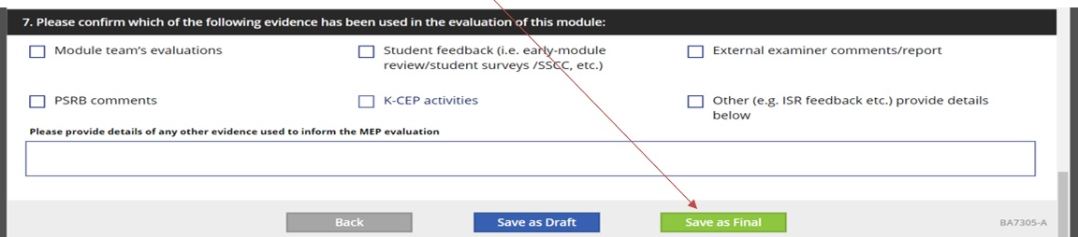
Your MEP is now saved as Final. Please wait a few minutes and a PDF of your final MEP will appear in the top right-hand corner of the screen.
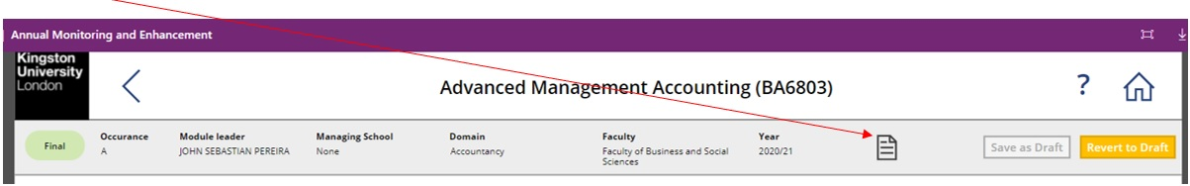

Sources of Help
There is a wealth of information on the Canvas Supporting the Kingston Continuous Enhancement Process pages which includes:
- An overview of the Kingston Continuous Enhancement Process (KCEP)
- Examples of how to write meaningful MEPs and examples of good MEPs.
- Recordings of briefing sessions for MEPs and CEPs
Sources of further information to inform your MEP:
- Data dashboards
- Data Insight and Analysis
- Access, Participation, and Inclusion
- Student Voice
- Graduate Outcomes, Employability
Help for IT specific queries via the IT Service Desk:
- Monday to Friday 8am to 6:30pm
- Telephone - internal ext.: 63355/ external +44(0)20 84173355
- Email ITS - Home / Service Desk Portal (kingston.ac.uk)
If your query remains unanswered, please contact the QAE Team at qae@kingston.ac.uk

Annex A Technical Specification
Code/heading | Description
Occurrence | Code to indicate a cohort of students taking the module
Element | Element (major category of assessment) for a module
Total number on module | Number of students with a Student Module Result (SMR) record
Total pass | Number of students with a module result of P (pass)
Total S | Number of students with an actual module grade of S (mitigating circumstances)
Total fail (excluding F0(0)) | (Number of students with an actual module grade of F0, F, FM, QF, FF, FZ, FL, Q0, QM, X0, ZM, X, XF, XL, XQ, Z) – (Number of students with an actual module grade of F0 and actual module mark <1)
Total F0(0) | Number of students with an actual module grade of F0(0)
Total W | Number of students with an actual module grade of W
Min mark (excluding F0(0)) | Minimum actual mark where actual grade is not null and actual mark >0
Max grade | Maximum actual mark
Average module mark (excluding F0(0), S and W) | Average of actual module mark where actual grade is not S or W, and actual grade is not null and (actual mark >0 and actual grade is F0) or (actual grade is not F0)
STD of Module Marks (excluding F0(0), S and W) | Standard deviation of actual module mark where actual grade is not S or W, and actual grade is not null and (actual mark >0 and actual grade is F0) or (actual grade is not F0)
Average Mark element 1 | Average of initial actual element mark
E1 average (excluding F0(0), S and W) | Average of initial actual element mark where actual grade is not null and grade is not F0, S or W

Annex B Data Explanation
M1 | Module fail rate at the 1st attempt | The total number of students who have not passed at first attempt/ total number of students on the module.  The count of students with a Module result where the current attempt at the module is greater than the complete attempt, where the complete attempt is greater than 0.  This excludes students who have Transferred from the Module. The total number of students on the Module is determined as those students having a Module Result record in SITS for the Module, Year, Occurrence and Period slot,  It includes Withdrawn students.
M2 | Module pass rate at 1st attempt | The number of students who pass at 1st attempt/ total number of students on the Module.  The number of students who pass at 1st attempt is the count of students with a pass result on their Module Result record and with a Current Attempt of 1.  The total number of students on the Module is determined as those students having a Module Result record in SITS for the Module, Year, Occurrence and Period Slot.  It includes Withdrawn students, students with Mitigating Circumstances are excluded.
M3 | Total number of students with mitigating circumstances at the 1st attempt | Total number of students who are flagged as having Mitigating Circumstances on their Module Result record, where the current attempt is 1.  Mitigating Circumstances are identified by an S grade in the Actual Grade on their Module Result record.
M4 | Total number of students with F0(0) following the first attempt | Number of students with an Agreed Grade on their Module Result record, an Agreed Mark of 0 where the current attempt is 1.  These students have disengaged with the Module.
M5 | Total number of students who withdrew prior to the first attempt | Students with an Agreed Grade of W, or if the Agreed Grade is blank, an Actual Grade of W where the current attempt is 1.
M6 | Module pass rate | Number of students who pass at any attempt/ total number of students on the Module. The total number of students who pass at any attempt at the Module.  This will increase following reassessment as results are entered. The total number of students on the Module is determined as those students having a Module Result record in SITS for the Module, Year, Occurrence and Period Slot. It includes Withdrawn students.

