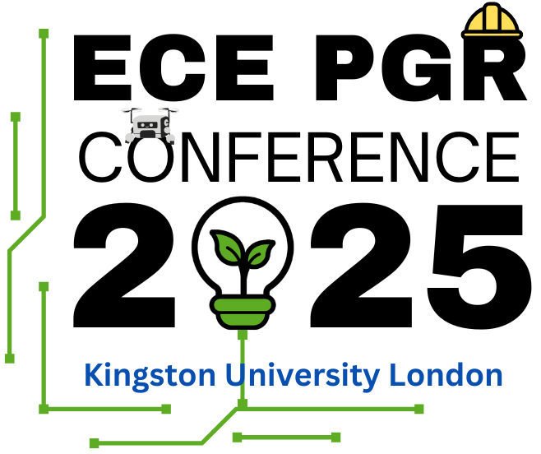
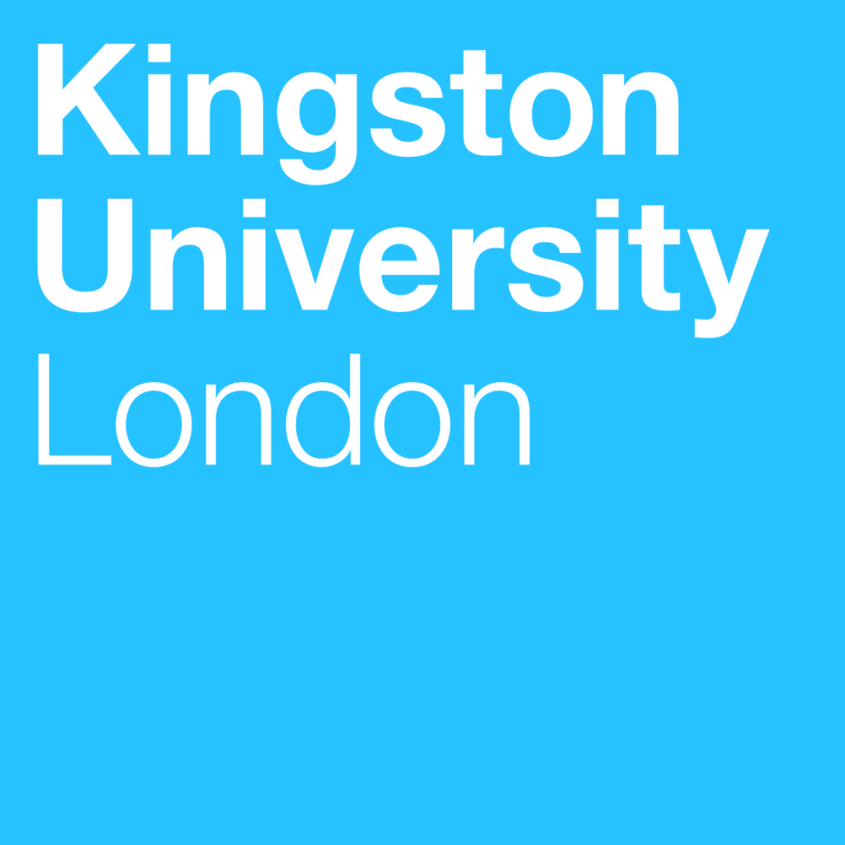

Faculty of Engineering, Computing, and the Environment (ECE)
Postgraduate Research Conference 2025

Please submit the abstract form by the 23rd of May on the CMT portal (instructions are provided in the Submission details)

Full Name:
KU Student Number:
Year of Study:
Supervisor(s):
Main Supervisor (1st) Signature:
School/Department:
Presentation Title:
UN Sustainable Development Goals (SDG):  source- https://sdgs.un.org/goals | Please specify SDG goal(s) (e.g., SDG 9: Build resilient infrastructure, promote inclusive and sustainable industrialization and foster innovation)
Preferred Format: | Oral |  | Poster Presentation
Abstract (350-word limit):

Publication Record:

