External examiner’s guide to accessing Kingston University systems
Contents
External examiner’s guide to accessing Kingston University systems 1
Introduction to Canvas 1
Logging in to Canvas 1
Finding your way around Canvas 3
Viewing assignment briefs 3
Viewing your sample of student work 3
Introduction to SharePoint/ OneDrive 7
Logging in to SharePoint/OneDrive 7
Finding your way around SharePoint/ OneDrive 8
Additional support and resources 8

Introduction to Canvas
Canvas is the University’s virtual learning environment (VLE) where teaching and learning content and activities are held and where students make assessment submissions and receive grading and feedback. The VLE is an integral part of the student experience at Kingston.

Canvas may be accessed via a PC, Mac, tablet or mobile phone.

With the exception of draft assessments and model solutions, all module materials should be shared with you via Canvas. This includes:
- Information about the module (Canvas module guide, current validated module descriptor, module enhancement plan)
- Assessment (links to assessment briefs, marking criteria/ mark schemes, assessment rubrics)
- Sample of assessed/ internally moderated student work (indicated using the ‘Notes’ column in Canvas Gradebook), including evidence of internal moderation.

Logging in to Canvas
You will have been automatically enrolled on the Canvas modules for which you are responsible. If for any reason you do not see the module you need, please contact the Module Leader, who can manually enrol you onto the module.

- Navigate to Canvas at https://canvas.kingston.ac.uk via your web browser, preferably Microsoft Edge.
- You will see the Canvas log in screen. Enter your KU email address, using your KU number plus “@kingston.ac.uk” (e.g. KU12345@kingston.ac.uk) and press ‘Next’.
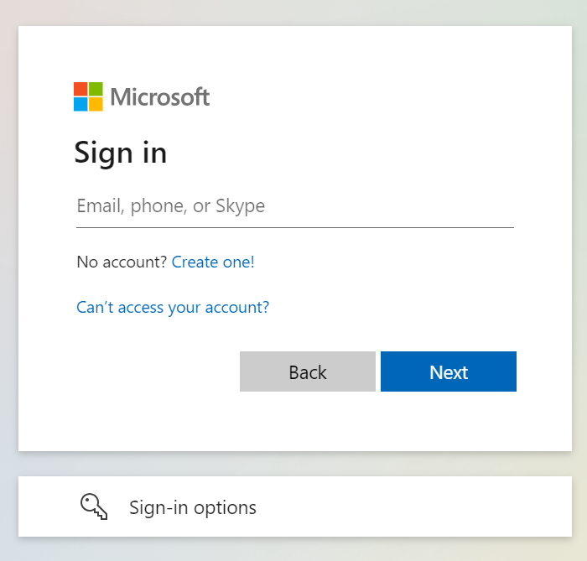

- Enter your password. If you need to reset your password, the link is: Password reset tool.
- You may then be asked to approve the login request using the Microsoft Authenticator app.
- If this leads to you signing on to your own University or company’s Canvas account, then please start again, but use an ‘incognito’ browser in Chrome, or ‘InPrivate’ in Edge. We do not recommend using Safari.
- If this fails and you need further help, then please contact IT services on 020 8417 3355 between 08:00 and 18:30, Monday to Friday.

Finding your way around Canvas
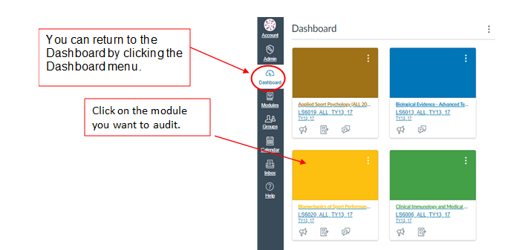Once logged in you will see the Dashboard, which will list your Canvas modules. Select the module you are auditing. If you don’t see a module you need access to, click the “Modules” button, then “All modules”. If you still don’t see the module you need, contact the Module Leader who can add you to the Canvas module.

Viewing assignment briefs
Select “Assignments” on the left-hand menu and click on the relevant assignment to view the brief.

Note: the order of the menu on the left may be different in different modules.

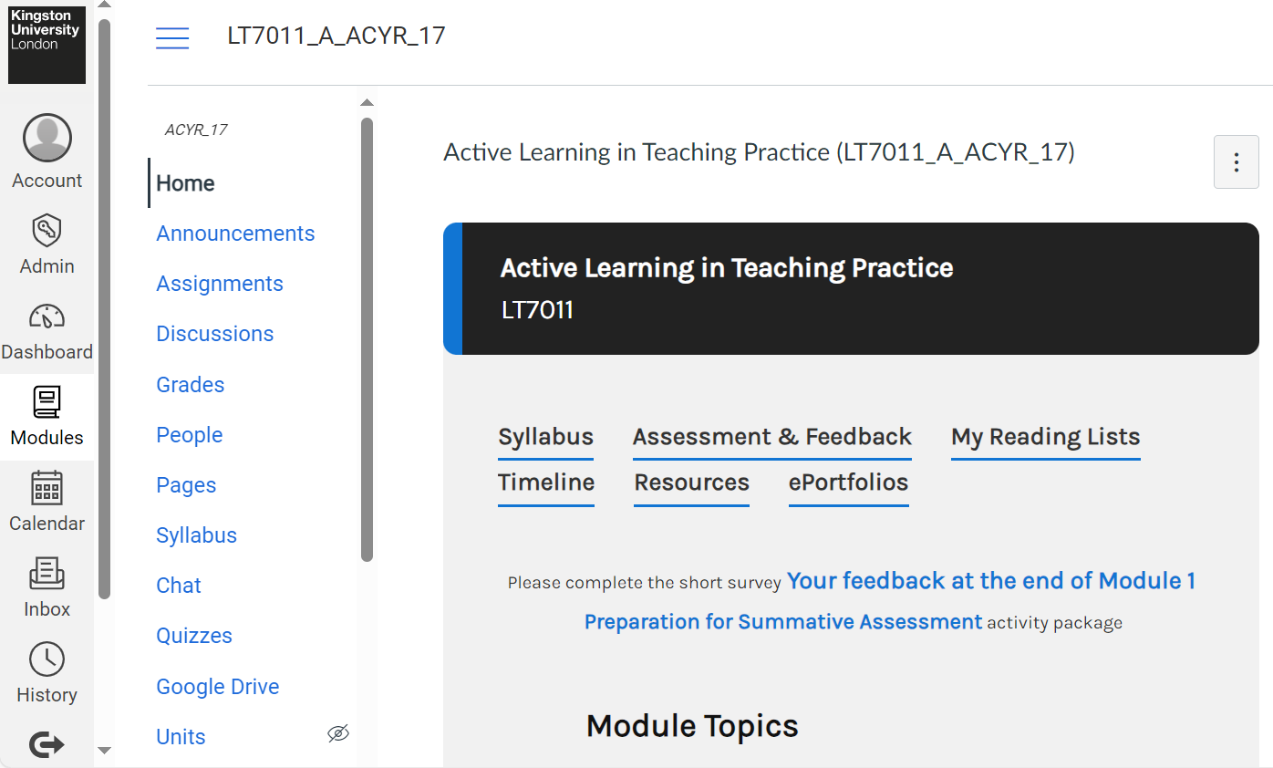

Viewing your sample of student work
Specific submissions have been identified for review to ensure that subject external examiners are provided with the internally moderated sample of work from each classification and representing all sites of delivery. To find which submissions to review, please follow these steps.

- On the left-hand side of the Canvas module, click “Grades”.
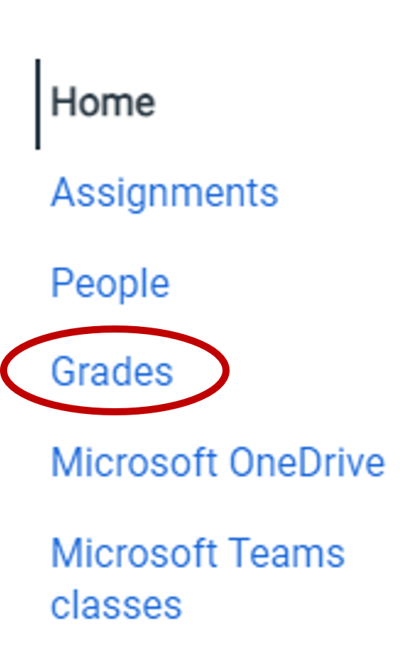

You will see the module Gradebook, which will look something like this:
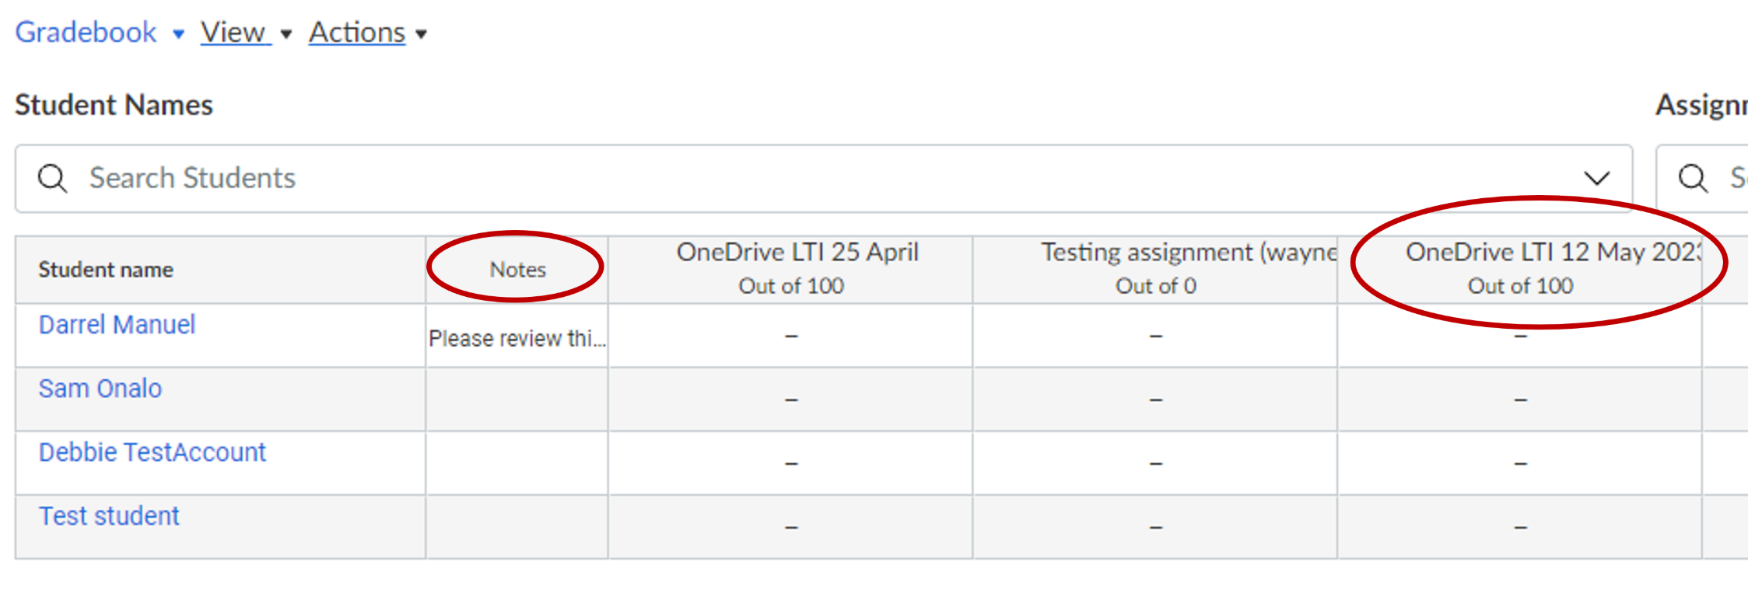

- Find the Notes column (directly to the right of the student names). The sample of student work for your review is indicated in this column. You can click and drag on the right border of that column to make it bigger.

The “Notes” for each student will tell you which assignment to review.

- Find the column for that assignment, and hover your mouse over the name of the assignment. You will see 3 vertical dots.

- Click on the 3 dots and then click “SpeedGrader”.

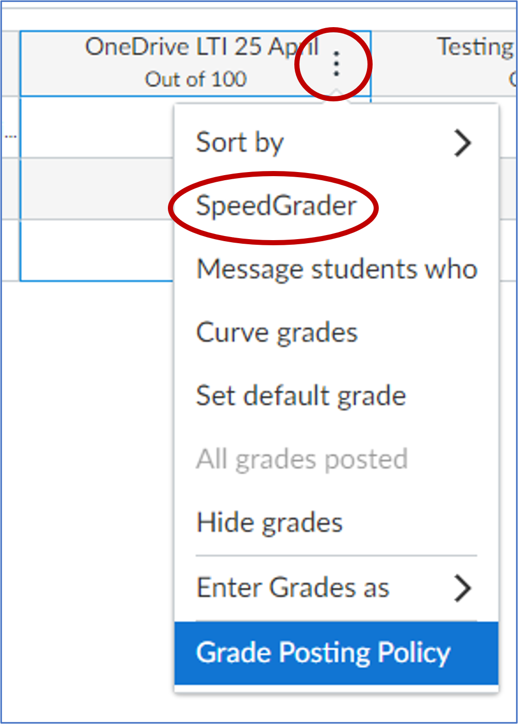

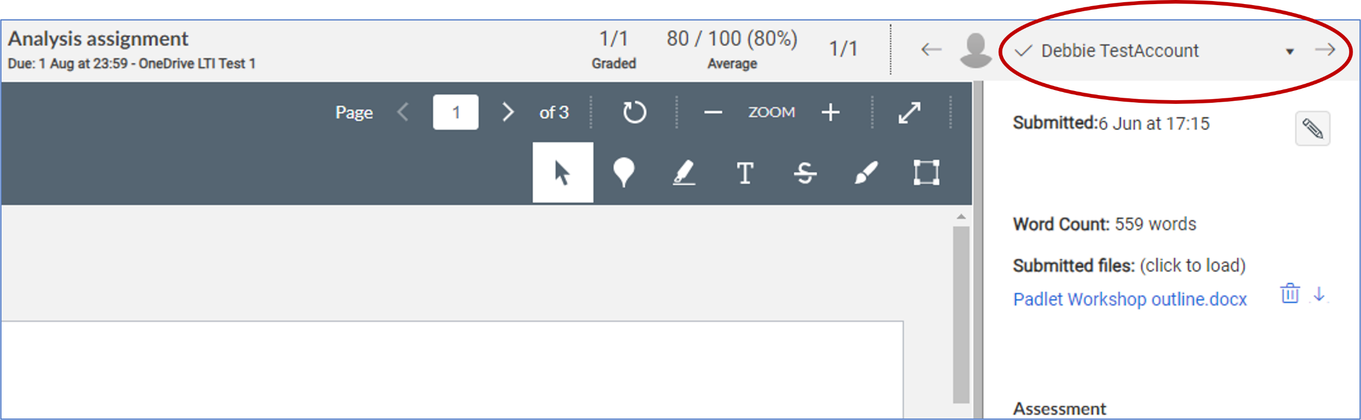
- Once in SpeedGrader, use the menu in the upper-right corner to find the student whose submission you are reviewing. Click the down triangle to see the list of students.

- There are multiple elements of feedback:

Assignment comments: Overall comments made about the assignment can be found in the bottom right-hand corner of the screen.

In-line comments: In-line comments can be left throughout the body of the assignment, linked to a section of text or individual word.

Rubric: Rubrics are used to standardise grading and make clear to the student the areas which the assignment seeks to consider. Note: not all assignments will be graded with rubrics.
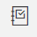
- When you have reviewed the assignment, click the browser back button or the Gradebook icon (in the upper-left corner) to return to Grades.

How to turn off Canvas Notification emails

To avoid receiving multiple Canvas notifications, click the “Account” button at the top left of the screen, and then click Notifications.
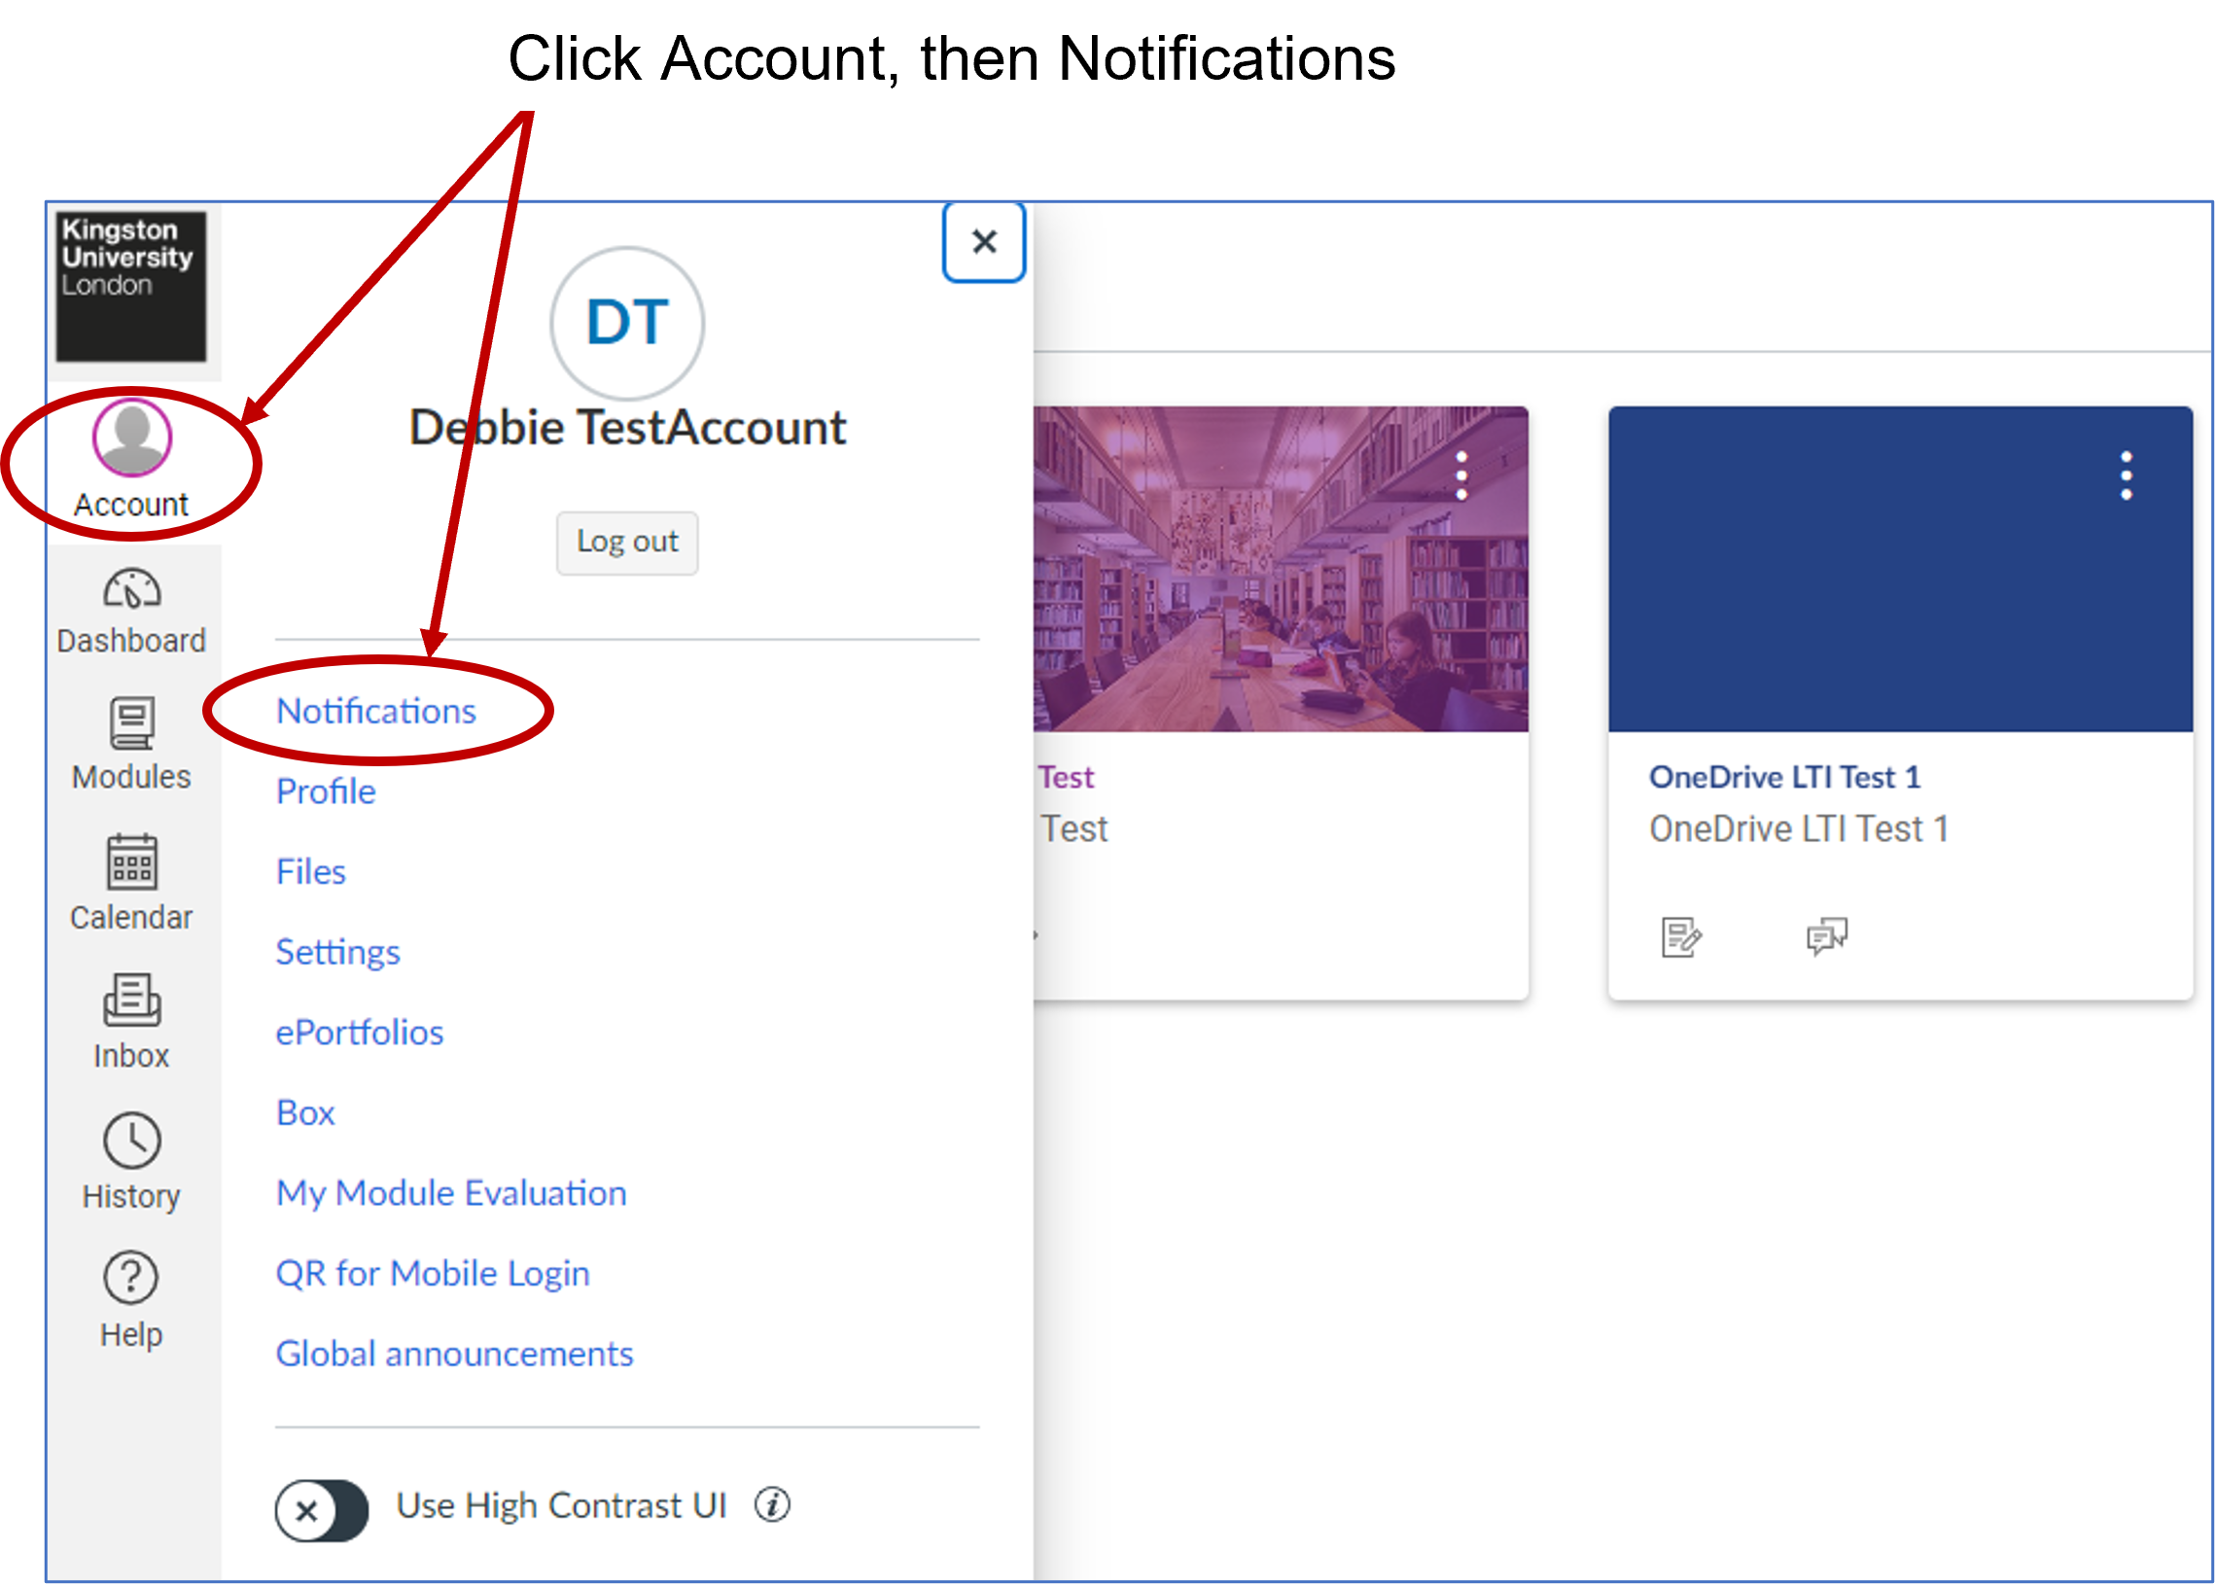

You will see a list of different types of notifications. A notification that is turned off looks like a bell with a slash through it (C in the image below).

To turn off a notification, click on the green icon and a menu with four options appears (A). Click “Notifications off”, as in the screenshot below (B).
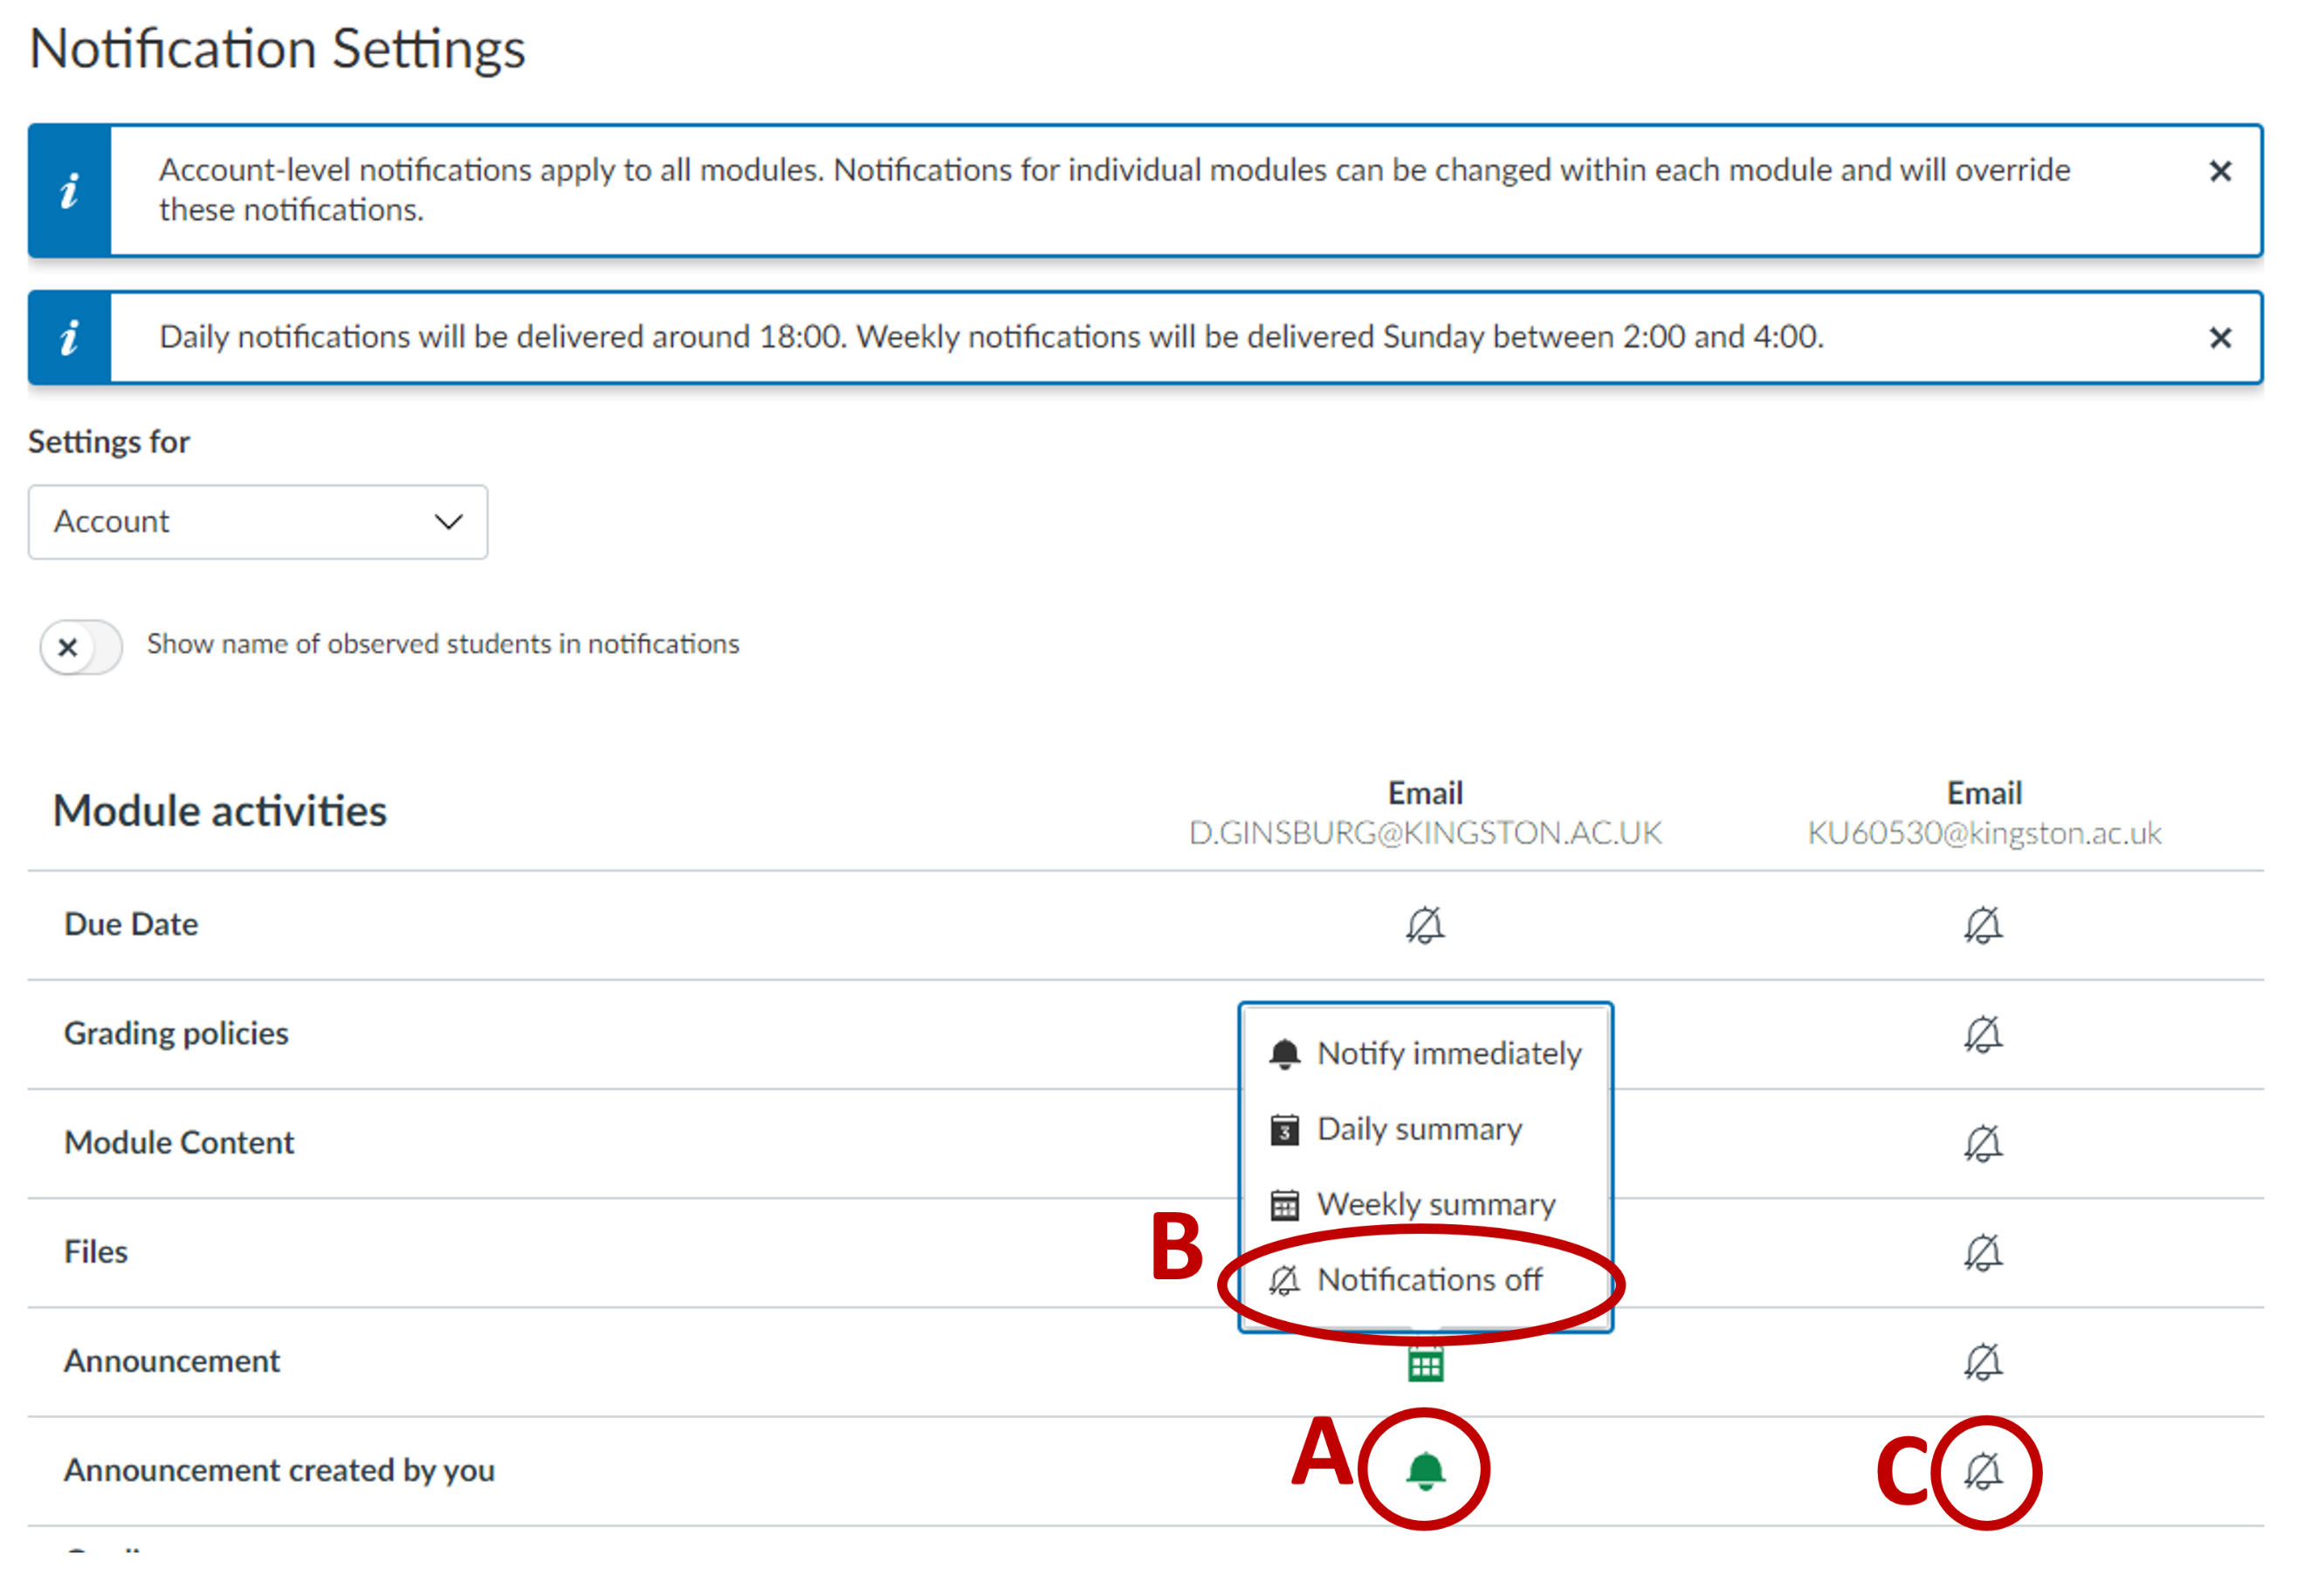

Introduction to SharePoint/ OneDrive
Microsoft SharePoint/ OneDrive is the University’s file storage system (previously Box).

Logging in to SharePoint/OneDrive
- Navigate to Microsoft office at www.office.com via your web browser, preferably Microsoft Edge.
- You will see the Microsoft sign in screen. Enter your KU email address, using your KU number plus “@kingston.ac.uk” (e.g. ku12345@kingston.ac.uk) and press ‘Next’.

- Enter your password and click sign in.
- You may then be asked to approve the login request using the Microsoft Authenticator app.

Finding your way around SharePoint/ OneDrive
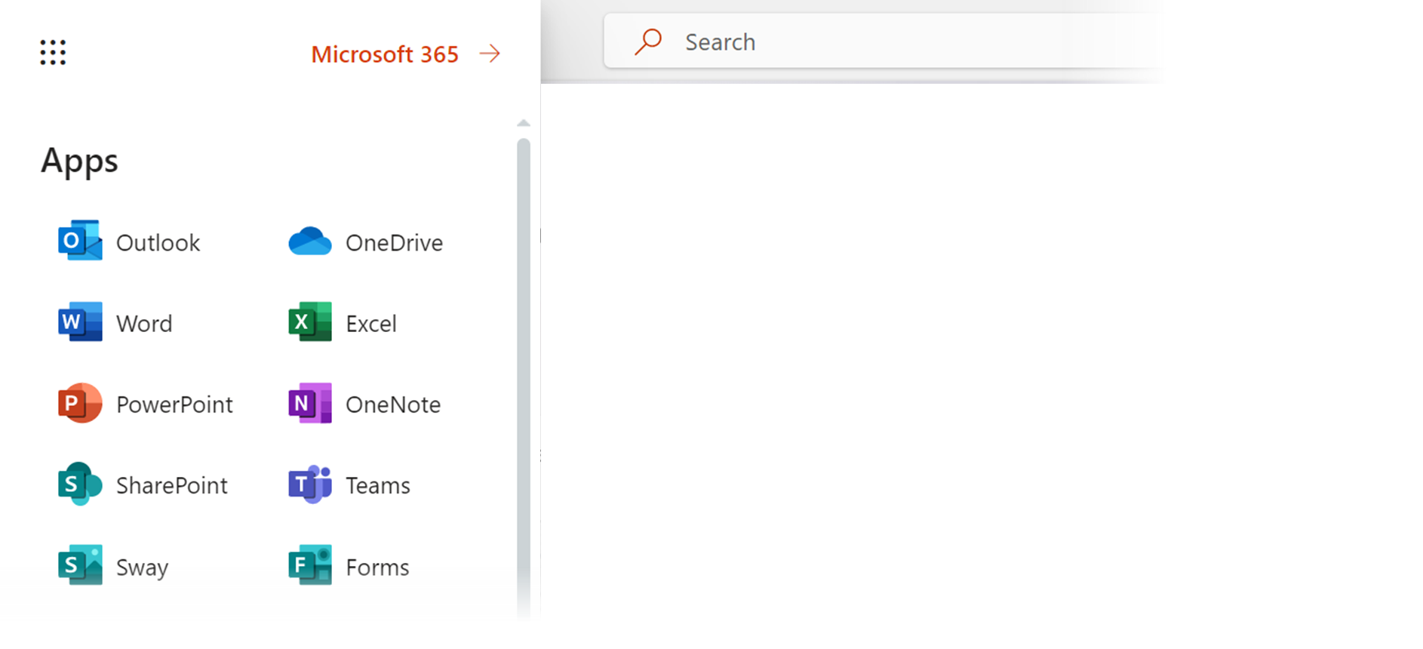



Some module materials may be shared with you via a private ‘External Examining’ SharePoint folder e.g. draft assessments and model solutions. Where that is the case, the Course or Module Leader will grant you access to the private folder and send you a direct link via email.

If files are shared with you via a Course or Module Leader’s personal OneDrive folder, as opposed to the private SharePoint folder, further guidance on viewing files shared with you in OneDrive is available viathis link: See files shared with you in OneDrive - Microsoft Support.

Please note that external examiners do not have a Kingston University Outlook email account and would not be expected to access Outlook via the KU ID. All emails sent to external examiner accounts will be auto-forwarded to your nominated email address.

Additional support and resources
If you would like to learn more about navigating around Canvas, setting up your profile, etc, please enrol on the Canvas Training module.

The University also has a wealth of Microsoft support and training resources for OneDrive and SharePoint. Please navigate to: Support and Education Resources (sharepoint.com).

If you have any queries at all, please contact the University’s IT Service Desk.

