­

|  |  |  |  |  |  |
| --- | --- | --- | --- | --- | --- |
| **Section 1: To be completed by the student** | | | | | |
| Full Name: | | | KU Number: | | |
| GP Name & Address: | | | Course: | | |
| **Dates not fit to study, from: ______________________to: ______________________** | | | | | |
| Brief description of symptoms/condition: | | | | | |
| **Authorisation:** I agree to the doctor issuing confirmation of my attendance at the GP Surgery and any appropriate information being provided to my faculty. | | | | | |
| Signed: | | | Date: | | |
|  | | | | | |
| **Section 2: To be completed by General Practitioner** | | | | | |
| Initial consultation date: | | Presenting condition: | | | |
| **Period of time affected by condition, from: __________________to: ___________________** | | | | | |
| **Mitigating Circumstances are specific circumstances that are:**   * sudden, serious and unpredictable and/or * relevant to an individual student and * likely to seriously impair the student’s performance and * taking place at the same time as an assessment event or before an assignment deadline * **Ongoing conditions are not considered Mitigating Circumstances unless they are a recent worsening/fluctuation of the condition** | | | | | |
| Is this a worsening or fluctuation of an ongoing condition? | | | | |  |
| In my opinion this condition **would** have affected the student’s academic studies between the above dates: | | | | |  |
| It is **not possible to say** that this condition would have affected the student’s academic studies: | | | | |  |
| Further comments: |  | | | | |
| GP Name: | | | | GP Stamp | |
| Signed: | | | |
| Date: | | | |
| Form invalid without student and GP signatures, and official GP stamp. | | | |

**Mitigating Circumstances**

Please check the University regulations before you make a claim. <http://www.kingston.ac.uk/aboutkingstonuniversity/howtheuniversityworks/policiesandregulations/mitigating-circumstances-and-extensions-regulations/>

Complete a claim for mitigating circumstances on OSIS <https://osis.kingston.ac.uk/>

The first and last date you were unable to engage with your course.

If this has resulted in a long period of time missed or you are unsure when you will be able to return to your studies, please consider an interruption of your studies, information is available here: <http://www.kingston.ac.uk/aboutkingstonuniversity/howtheuniversityworks/policiesandregulations/general-regulations/>

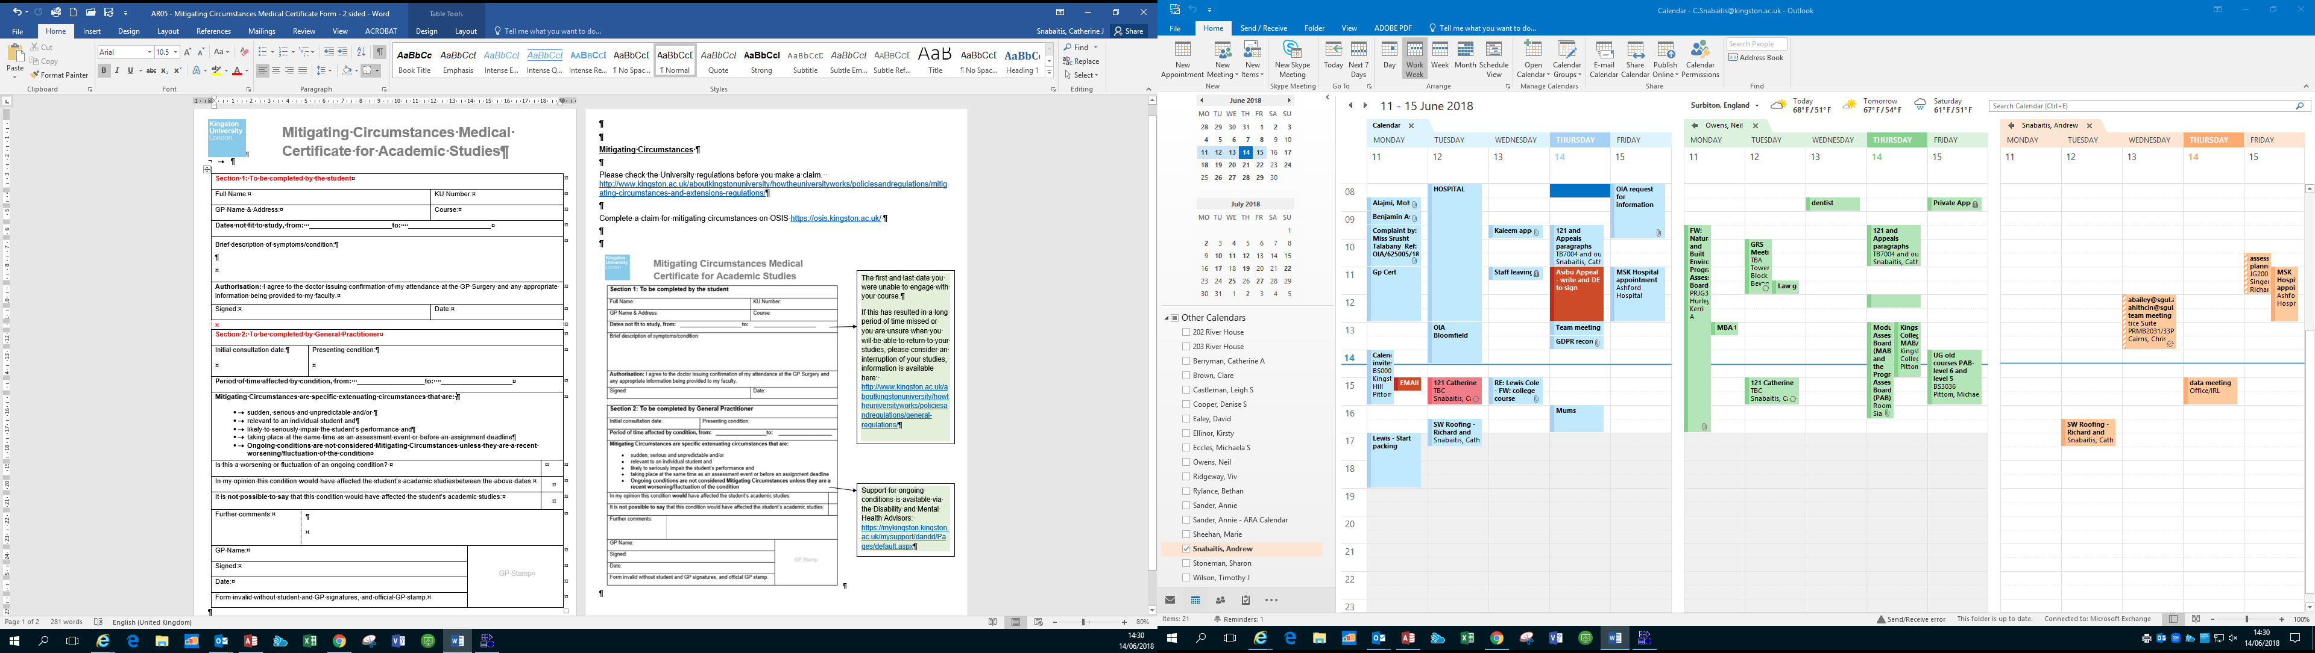

Support for ongoing conditions is available via the Disability and Mental Health Advisors: <https://kingstonuniversity.sharepoint.com/sites/mykingston/mysupport/studentwellbeing/Pages/disabilityavaliablesupport.aspx>