**Harry Potter & the Order of British Icons**

**Summer 2025 Group B:** Tuesdays & Thursdays **/ Module Code:** SS1818

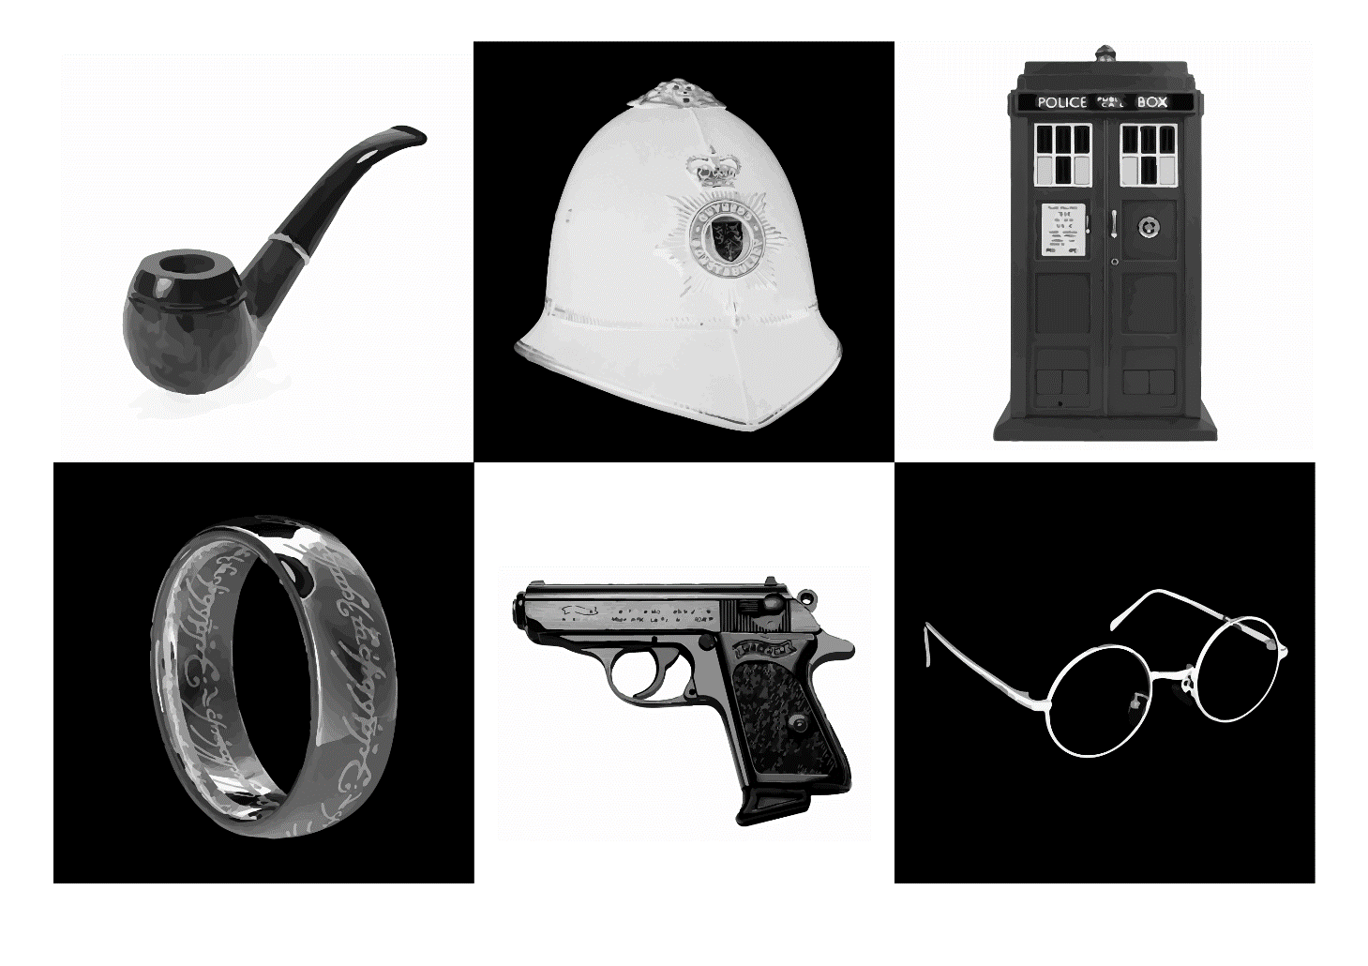

**Module Leader**

**Nick Foxton**

[**N.foxton@kingston.ac.uk**](mailto:N.foxton@kingston.ac.uk)

**Aims**

1. To provide the opportunity for students to develop an understanding and appreciation of key British icons through film, TV and literature;
2. To consider selected texts within the specific historical, political and cultural context of Britain over the past 150 hundred years and to evaluate the significance of popular icons within the national culture;
3. To explore changing attitudes to gender, class and sexuality through the study of specific British icons;
4. To appreciate the ways in which a study of popular culture can produce alternative cultural histories;
5. To introduce students to key cultural and historical sites in London in relation to these texts and to encourage students to view such places in an informed and critical way.

## Learning outcomes

On completion of the course students should be able to demonstrate:

1. An understanding of the prevalence of certain character types from the 19th century to the present;
2. An awareness of how popular British icons reflect changing social attitudes;
3. A knowledge of a range of relevant texts;
4. An ability to write critically and persuasively about the issues raised in the module, and to undertake independent research.

## Teaching and learning strategies

The course is delivered through a multidisciplinary programme consisting of:

1. Formal lecture/workshop and seminar/small group sessions
2. Field activities led by members of the Kingston Faculty or contracted professionals
3. Independent library sessions

**Classes**

1. Classes will start promptly at the times shown in the schedule.
2. There will be a preliminary meeting on **Friday afternoon, 4 July**, to make sure all is in order before classes start on the Monday.
3. For all the field trips to London you will travel on public transport using your travel cards.

**N.B. The University reserves the right to vary or revise the content at its discretion.**

**Module Tutors:**

**Elly Bavidge:** [**e.bavidge@kingston.ac.uk**](mailto:e.bavidge@kingston.ac.uk)

**Matt Cunningham:** [**m.cunningham@kingston.ac.uk**](mailto:m.cunningham@kingston.ac.uk)

## Harry Potter & the Order of British Icons (2025)

|  |  |  |  |  |
| --- | --- | --- | --- | --- |
| **Date** | **Time** | **Place** | **Lecture** | **Lecturer** |
| **Fri**  **4th July** | 2pm-4:00pm | KPTK | Introduction: British heroes – what can they tell us about Britain today | Nick Foxton |
| **Tues**  **8th July** | 10.30am -  1.30pm | KPTK | Heroes & Heroines for the Present: Reading Harry Potter | NF |
| **Thurs**  **10th July** | 10am -  1pm | Embankment | **Harry Potter Walking Tour** | NF |
| **Tues**  **15th July** | 10.15am to leave by 10.30am  12pm –  6pm | Middle Mill  Warner Bros. Studios | **Meet minibus**  **Harry Potter Studio Tour** |  |
| **Thurs**  **17th July** | 10am- 12.30pm | KPTK | Beyond Bond: How Britain got Better | Elly Bavidge |
| **Tues**  **22nd July** | 10am -  1pm  3.15pm for 3.30pm entry | KPTK  221b Baker St, Marylebone,  NW1 6XE | The Great Detective  **Sherlock Holmes Museum** | NF  Bernice Ebolum |
| **Thurs**  **24th July** | 10am- 12pm  2.15pm –  5pm | KPTK | Fan Studies (joined by Creative Writing students)  **Performance tbc** | Matt Cunningham |
| **Tues**  **29th July** | 2pm - 4pm  7.30pm -  9.30pm | KPTK | Doctor Who & the Regenerating Hero  **Evening performance tbc** | NF |
| **Thurs**  **31st July** | 10am – 12pm | KPTK | Summary | NF |

**Assessment and Questions**

**Paper 1 Creative (50%) max 1500 words**

Students will be asked to write a personal or creative piece to themes studied in the course, in response to one of the prompts given in Week 1. It will be submitted on **Thursday 24th July at 11.59pm**

**Paper 2 Critical (50%) max 1500 words**

Students will be asked to write an essay in response to one of the questions on the topics covered during the module, released in Week 1. It will be submitted on **Thursday 31st July by 11.59pm**

**NB You may not write on any topic which you are writing on for another course you are taking in Summer School.**

**NB Those taking the two-week course are asked to write a max of 750 words for each paper. For Paper 2, if you choose to answer prompt (1), please offer only ONE close analysis of text.**

**Attendance**

You are expected to attend all lecture sessions and group trips. Up to a maximum of 20% will be deducted from the final overall grade for non-excused absences from lectures and fieldtrips. This will be at the rate of 3% for each **unexcused** absence.

**Paper 1 Creative (50%) max 1500 words**

**Write a 1,500-word response to ONE of the following creative/personal prompts:**

1. Write **a personal essay on an icon of your choice**, exploring the way in which that icon impacted a moment in your life. In the course of the personal essay you should draw on at least two of the following in relation to the icon and/or its creator

* historical context of the icon
* biographical context of its creator
* scholarly writing on the icon
* wider theoretical frameworks
* your own close analysis of the original text

in order to illuminate your personal response. You should include a bibliography/works cited, but you do not have to write in an academic style. The icon does not have to be one explored on the course, but if it is not please have your choice of icon approved in advance by the course leader.

1. Write **the first chapter of an original piece of fanfiction** of *either*

* a Harry Potter novel, *or*
* a Sherlock Holmes story.

You might choose to set your fiction in the contemporary milieu of the original work, or in modern times. You should aim to recreate the style and/or tropes of the original author in a brand new piece of work.

1. Write **a complete short story** that offers an original contribution to *one* of the following genres:
   * school stories
   * fantasy stories
   * detective stories
   * spy stories
   * horror stories
   * true-crime stories
   * historical fiction.
2. Write **a film treatment** outlining the plot of a new

* James Bond film, or
* episode of *Doctor Who*

Your treatment should keep in the spirit of the source, while offering an original iteration. You might write for a previous incarnation of the original character, or propose a new British actor to take on the role.

**DUE:** Thursday 24th July**,** 11.59pm

**Paper 2 Critical (50%) max 1500 words**

**Write a 1,500-word essay in response to ONE of the following prompts:**

1. Write TWO close textual analyses of 750 words each, in response to two of the passages reproduced in the appendix below.
2. Identify a text, film, historical figure or event that has influenced one of the texts studied on the course. With close reference to both, demonstrate how this influence has been absorbed and re-imagined to create something new.
3. “Mythology shows itself to be as amenable as life itself to the obsessions and requirements of the individual, the race, the age”: prove or disprove this statement with reference to any of the texts that we have studied.
4. Choose ONE hero from those that we have studied and examine their depiction(s) in popular culture through the lens of ONE of the following: gender, class or politics.
5. “Some degree of redemption has to be possible”: choose ONE villain from those whom we have studied and write a reasonable defence of their actions.
6. Analyse the depiction in art (whether visual, sculpture, film, literature or stage play) of a living or historical British icon. How does the artist interpret the icon in their chosen medium?
7. Choose a character in British film or fiction from a marginalised or under-represented group. Explain why they ought to be celebrated as an icon.
8. In what ways could the books and/or films we have studied be considered particularly British? Please consider their themes and cultural contexts.
9. How has London informed and shaped the texts studied? Please consider particular London locations, transport, and local and broader history.

**DUE:** Thursday 31st July, 11.59pm

**APPENDIX**

For Paper 2, prompt (1), you are asked to write two 750-word close textual analyses, one each from the following options. **NB. If you are taking the two-week course and answering this prompt, choose and respond to only one of the following options.**

Use the text as a springboard for your own observations. You might think about some of the following: What do the extracts reveal about the work’s themes, ideas and characters? What effects does the writer create through language, image, tone and structure? What might these words suggest about the historical, social or political context in which they were written? What is their subtext? What might this sliver of narrative suggest about the characters’ position in the wider story of British popular culture?

**Extract 1**

Fudge had talked for more than an hour. At one point, he had refused to say a certain name aloud and wrote it instead on a piece of parchment, which he had thrust into the Prime Minister’s whiskey-free hand. When at last Fudge had stood up to leave, the Prime Minister had stood up too.

“So you think that…” He had squinted down at the name in his left hand. “Lord Vol—”

“*He-Who-Must-Not-Be-Named!*” snarled Fudge.

“I’m sorry… You think that He-Who-Must-Not-Be-Named is still alive, then?”

“Well, Dumbledore says he is,” said Fudge, as he had fastened his pin-striped cloak under his chin, “but we’ve never found him. If you ask me, he’s not dangerous unless he’s got support, so it’s Black we ought to be worrying about. You’ll put out that warning, then? Excellent. Well, I hope we don’t see each other again, Prime Minister! Good night.”

But they had seen each other again. Less than a year later a harassed-looking Fudge had appeared out of thin air in the cabinet room to inform the Prime Minister that there had been a spot of bother at the Kwidditch (or that was what it had sounded like) World Cup and that several Muggles had been “involved,” but that the Prime Minister was not to worry, the fact that You-Know-Who’s Mark had been seen again meant nothing; Fudge was sure it was an isolated incident, and the Muggle Liaison Office was dealing with all memory modifications as they spoke.

“Oh, and I almost forgot,” Fudge had added. “We’re importing three foreign dragons and a sphinx for the Triwizard Tournament, quite routine, but the Department for the Regulation and Control of Magical Creatures tells me that it’s down in the rule book that we have to notify you if we’re bringing highly dangerous creatures into the country.”

“I—what—*dragons?”*  spluttered the Prime Minister.

“Yes, three,” said Fudge. “And a sphinx. Well, good day to you.”

The Prime Minister had hoped beyond hope that dragons and sphinxes would be the worst of it, but no. Less than two years later, Fudge had erupted out of the fire yet again, this time with the news that there had been a mass breakout from Azkaban.

“A *mass* breakout?” repeated the Prime Minister hoarsely.

“No need to worry, no need to worry!” shouted Fudge, already with one foot in the flames. “We’ll have them rounded up in no time—just thought you ought to know!”

And before the Prime Minister could shout, “Now, wait just one moment!” Fudge had vanished in a shower of green sparks.

Whatever the press and the opposition might say, the Prime Minister was not a foolish man. It had not escaped his notice that, despite Fudge’s assurances at their first meeting, they were now seeing rather a lot of each other, nor that Fudge was becoming more flustered with each visit. Little though he liked to think about the Minister of Magic (or, as he always called Fudge in his head, the *Other* Minister), the Prime Minister could not help but fear that the next time Fudge appeared it would be with graver news still. The sight, therefore, of Fudge stepping out of the fire once more, looking disheveled and fretful and sternly surprised that the Prime Minister did not know exactly why he was there, was about the worst thing that had happened in the course of this extremely gloomy week.

From *Harry Potter and the Half-Blood Prince* (2005) by J K Rowling

**Extract 2**

To Sherlock Holmes she is always *the* woman. I have seldom heard him mention her under any other name. In his eyes she eclipses and predominates the whole of her sex. It was not that he felt any emotion akin to love for Irene Adler. All emotions, and that one particularly, were abhorrent to his cold, precise but admirably balanced mind. He was, I take it, the most perfect reasoning and observing machine that the world has seen, but as a lover he would have placed himself in a false position. He never spoke of the softer passions, save with a gibe and a sneer. They were admirable things for the observer—excellent for drawing the veil from men’s motives and actions. But for the trained reasoner to admit such intrusions into his own delicate and finely adjusted temperament was to introduce a distracting factor which might throw a doubt upon all his mental results. Grit in a sensitive instrument, or a crack in one of his own high-power lenses, would not be more disturbing than a strong emotion in a nature such as his. And yet there was but one woman to him, and that woman was the late Irene Adler, of dubious and questionable memory.

I had seen little of Holmes lately. My marriage had drifted us away from each other. My own complete happiness, and the home-centred interests which rise up around the man who first finds himself master of his own establishment, were sufficient to absorb all my attention, while Holmes, who loathed every form of society with his whole Bohemian soul, remained in our lodgings in Baker Street, buried among his old books, and alternating from week to week between cocaine and ambition, the drowsiness of the drug, and the fierce energy of his own keen nature. He was still, as ever, deeply attracted by the study of crime, and occupied his immense faculties and extraordinary powers of observation in following out those clues, and clearing up those mysteries which had been abandoned as hopeless by the official police. From time to time I heard some vague account of his doings: of his summons to Odessa in the case of the Trepoff murder, of his clearing up of the singular tragedy of the Atkinson brothers at Trincomalee, and finally of the mission which he had accomplished so delicately and successfully for the reigning family of Holland. Beyond these signs of his activity, however, which I merely shared with all the readers of the daily press, I knew little of my former friend and companion.

From “A Scandal in Bohemia” (1891) by Arthur Conan Doyle

**Extract 3**

Gollum looked up.  A dark water was before him, and he was crawling on the ground, this way and that, doubtful of the way. “Yes, they are all round us,” he whispered. “The tricksy lights. Candles of corpses, yes, yes. Don't you heed them! Don't look! Don't follow them! Where's the master?”

Sam looked back and found that Frodo had lagged again. He could not see him. He went some paces back into the darkness, not daring to move far, or to call in more than a hoarse whisper. Suddenly he stumbled against Frodo, who was standing lost in thought, looking at the pale lights. His hands hung stiff at his sides; water and slime were dripping from them.    
 “Come, Mr. Frodo!” said Sam.  “Don't look at them!  Gollum says we mustn't. Let's keep up with him and get out of this cursed place as quick as we can – if we can!”    
 “All right,” said Frodo, as if returning out of a dream.  “I'm coming. Go on!”    
 Hurrying forward again, Sam tripped, catching his foot in some old root or tussock.  He fell and came heavily on his hands, which sank deep into sticky ooze, so that his face was brought close to the surface of the dark mere. There was a faint hiss, a noisome smell went up, the lights flickered and danced and swirled.  For a moment the water below him looked like some window, glazed with grimy glass, through which he was peering. Wrenching his hands out of the bog, he sprang back with a cry. “There are dead things, dead faces in the water,” he said with horror. “Dead faces!”    
 Gollum laughed. “The Dead Marshes, yes, yes: that is their names,” he cackled. “You should not look in when the candles are lit.”    
 “Who are they? What are they?” asked Sam shuddering, turning to Frodo, who was now behind him.    
 “I don't know,' said Frodo in a dreamlike voice. “But I have seen them too. In the pools when the candles were lit. They lie in all the pools, pale faces, deep deep under the dark water. I saw them: grim faces and evil, and noble faces and sad. Many faces proud and fair, and weeds in their silver hair.  But all foul, all rotting, all dead. A fell light is in them.” Frodo hid  his eyes in his hands.  “I know not who they are; but I thought I saw    
there Men and Elves, and Orcs beside them.”    
 “Yes, yes,” said Gollum. “All dead, all rotten. Elves and Men and Orcs. The Dead Marshes. There was a great battle long ago, yes, so they told him when Sméagol was young, when I was young before the Precious came. It was a great battle. Tall Men with long swords, and terrible Elves, and Orcses shrieking. They fought on the plain for days and months at the Black Gates. But the Marshes have grown since then, swallowed up the graves; always creeping, creeping.”

From *The Two Towers* (1954) by J RR Tolkien