Section D

Kingston Continuous Enhancement Process (KCEP)

Contents
Forms and Templates 3
Guidance Notes 3
Abbreviations in this section 3
Introduction and summary 5
Purpose 8
Criteria 8
Key Performance Indicators and Key Management information 9
Kingston Continuous Enhancement Process StaffSpace Site 9
Module level Continuous Enhancement Process 10
The management of modules 10
Module Enhancement Plans (MEPs) 10
Responsibility for the MEP 10
When to write the MEP 11
Writing the MEP 11
External Examiners’ Reports 11
Student Feedback 11
Evidence used to write the MEP 11
MEP Action Plan 12
Modifications to modules resulting from the MEP 12
Course level Continuous Enhancement Process 12
The Course Enhancement Plan (CEP) 12
Responsibility for CEPs 13
Process for maintaining the Course Enhancement Plan (CEP) 13
Modifications to Courses and Modules resulting from the CEP 14
Process for Non-Credit Bearing (NCB) Provision 14
Oversight and governance of the course level Continuous Enhancement Process 15
Identification of ‘high risk’ courses 15
KCEP Review Meeting 16
Definition of support levels 17
Subject level Continuous Monitoring and Enhancement 18
Institution Level Continuous Monitoring and Enhancement 19
Continuous Monitoring and Enhancement of Collaborative Provision 19
Appendix 1 20
Arrangements for Continuous Monitoring and Enhancement of Collaborative Provision 20
Appendix 2 21
Overview of Kingston Continuous Enhancement Process (KCEP) 21
Appendix 3 22
Overview of course level continuous monitoring and enhancement 22

Forms and Templates

Form D1 | Module Enhancement Plan (MEP)
Form D2 | Course Enhancement Plan (CEP)
Form D3 | NCB Provision Enhancement Plan
Form D4 | School KCEP report
Form D5 | Faculty KCEP report

Guidance Notes

DG (i) | Performance indicators for continuous monitoring and enhancement
DG (ii) | Module Enhancement Plan (MEP) User Guide
DG (iii) | Course Enhancement Plan (CEP) User Guide

Abbreviations in this section

AMC | Apprenticeship Monitoring Committee
CEP | Course Enhancement Plan
CME | Continuous Monitoring and Enhancement
EC | Education Committee
FEC | Faculty Education Committee
FMG | Faculty Management Group
KCEP | Kingston Continuous Enhancement Process
KMIs | Key Monitoring Information set
KPIs | Key Performance Indicators
KRM | KCEP Review Meeting
LTEC | Learning and Teaching Enhancement Centre
MAB | Materially above benchmark
MALA | Masters Award by Learning Agreement
MIB | Materially in-line with benchmark
MEP | Module Enhancement Plan
MEQ | Module Evaluation Questionnaire
NCB | Non-credit bearing
NSS | National Student Survey
OfS | Office for Students
PSRB | Professional, Statutory and Regulatory Body
QAE | Quality Assurance and Enhancement
QAPCC | Quality Assurance Portfolio Change Committee
SEC | School Education Committee
SLT | Senior Leadership Team
SVC | Student Voice Committee

Introduction and summary

- Faculties (and their sub-units Schools, Departments, Course Teams) are primarily responsible for the academic quality assurance and enhancement of taught courses within their remit.

- The Kingston Continuous Enhancement Process (KCEP) is the institutional framework for quality enhancement, which fosters strong working relationships between course teams across all faculties and the professional services. It underpins the enhancement and monitoring of current courses and facilitates the showcasing of excellence in course delivery.

- The KCEP procedures are designed for use with all modules and courses governed by the Undergraduate Regulations and the Postgraduate Regulations.

- The process of continuous monitoring and enhancement provides an opportunity for review, reflection, and evaluation of the delivery of modules and courses and for identifying issues, risks and actions for improvement and enhancement. It also provides an opportunity for identifying and celebrating success, promoting best practice, and learning from each other.

- The course team maintains a continuous enhancement action plan to ensure that provision is at least high quality and to drive very high quality and outstanding student experiences and outcomes.

- The course team is responsible for regularly updating the continuous enhancement action plan in response to data and evidence relating to student experience and outcomes (at both overall and splits levels). This includes (and is not restricted to): NSS, MEQ, Student Forum feedback, continuation and completion (including internal indicators such as pass at first attempt and retention), Graduate Outcomes, student engagement or attendance rates, external examiner feedback, PSRB requirements, student numbers, and observations by the course team.

- The assessment of this evidence and translation into actions by course teams should be risk-based and enhancement focused. As such:
- We would expect to see remedial actions where evidence indicated that there may be a risk to high quality provision.
- We would expect to see enhancement actions where there is scope for further developing very high or outstanding provision.
- In either case (above), actions should be supported with appropriate data analysis in a comments section, to provide a rationale for the action.
- For areas that are low risk or not a priority for further enhancement, there is a lower expectation for actions and commentary.

- The Education Directorate will work with faculties to gain assurance that this process is conducted and to scrutinise action in any areas where the quality of student experience or outcomes are identified as at risk. This includes:
- Conducting a central analysis of data and highlighting to faculties areas of potential high risk.
- Scrutinising a risk-based sample of continuous action plans to ensure that appropriate actions are in place through regular KCEP Review Meetings.
- Assurance from senior faculty academic staff each academic year that quality assurance and enhancement processes are being properly completed.

- On the basis of the scrutiny of continuous action plans at a KCEP Review Meeting, normally one of the following outcomes will be agreed:
- The actions in the continuous action plan are appropriate, and no further action is required at this stage.
- The continuous action plan needs to be further developed to address the potential risk identified. Sign-off for these changes will be at School level.
- Due to the scale of the potential risk, a dedicated analysis and action plan are required (typically two sides of A4). Sign-off for this action plan will be at PVC level.
- Where the scale, depth or extent of risks is more significant, a Substantive Review or Internal Quality Audit may be agreed.

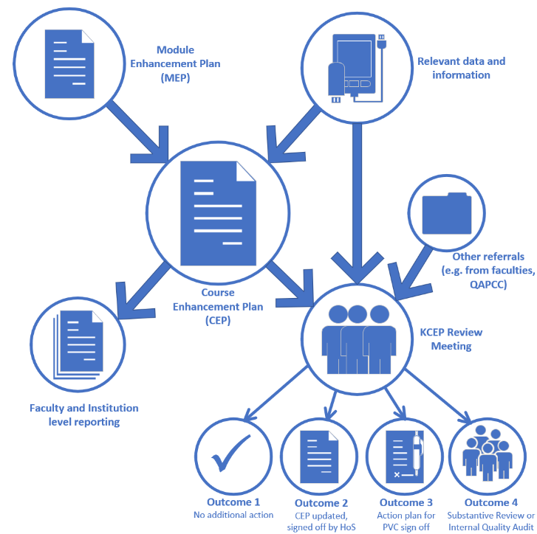

Purpose

- KCEP is the process by which the University is assured that all provision is meeting expectations in terms of student outcomes and student experience. It is a risk-based process, through which courses or subject areas which have either low or falling metrics can be identified for scrutiny, with options for escalation to higher levels of evaluation and review should existing action plans be considered inadequate.

- Its specific purposes are:
- To ensure that appropriate actions are in place to ensure continuous improvement in student outcomes and experience across all provision.
- To identify courses/subjects underperforming or at risk of underperforming and to take timely action to address the issues.
- To support staff in taking appropriate actions to address issues raised.
- To identify wider school, faculty or university level concerns.
- To support strategic decision making at faculty level and inform relevant University level discussions.
- To provide the University with monitoring accountability as one way of supporting it in fulfilling its responsibility for monitoring the quality and standards of academic awards made in its name.

- In developing continuous monitoring and enhancement procedures several principles have been adopted. These are as follows:
- To locate responsibility for quality assurance and enhancement as close as possible to the point of delivery.
- To provide a meaningful reflective and dynamic process that allows consideration of issues as they arise through the timely consideration of relevant external and internal metrics.
- To link effectively to the University strategic priorities and enhancement goals derived from the Town House Strategy.
- To incorporate clear processes of action planning, accountability, and follow-up of action plans.

Criteria

- KCEP applies equally to all University provision, including both credit-bearing and non-credit-bearing modules, delivered at the University and those delivered by UK and international collaborative partners.

- Non-Credit Bearing (NCB) provision, covered by this policy, refers to modules of study delivered by the University that do not award academic credit upon completion and the attendees are registered as students on the University’s student records system (SITS).

- NCB provision may facilitate student entry onto credit bearing provision or may be part of the curriculum of a validated credit bearing course.

- To enable monitoring and review, NCB provision must be set up on SITS.

- Individually negotiated modules contained within the Masters Award by Learning Agreement (MALA) Framework are not required to complete individual Module Enhancement Plans. However, all courses within MALA are required to complete a Course Enhancement Plan.

Key Performance Indicators and Key Management information

- A range of Key Performance Indicators (KPIs) have been developed to inform the continuous monitoring and enhancement process at both module and course level.

- These indicators articulate external and University-wide performance thresholds that are applied uniformly across the University’s provision to highlight potential areas of concern and to assist in the identification of areas for improvement and enhancement. Module and course KPIs are described in Guidance DG(i).

- During the academic year, the Course Leader will have access to a suite of Key Monitoring Information (KMI) that will assist in the continuous monitoring of each course. This will include, but is not limited to:
- External metrics (such as OfS B3 student outcomes data)
- External Examiner reports
- Reports from PSRBs (where applicable)
- Outcomes of KCEP Review Meetings and subsequent action plans
- Course performance data
- Module Enhancement Plans
- Student feedback:
- National Student Survey (NSS) results
- Feedback from course, school and faculty representatives via SVCs and other forums
- Progression and Award Board outcomes

Kingston Continuous Enhancement Process StaffSpace Site

- A dedicated Kingston Continuous Enhancement Process site facilitates the provision of pre-populated Module Enhancement Plans (MEPs) (for credit bearing modules only) and Course Enhancement Plans (CEPs) drawing on data from SITS and other external sources. For CEPs, the system operates at Course Group Level which is driven by the University’s Course Aggregation Model. This makes possible the production of a combined CEP for all cognate courses in a cluster e.g., FT, PT, with professional placement etc. It is the expectation that CEPs will be completed at the Course Group level.

- The KCEP site stores all MEPs (for credit-bearing modules only) and CEPs. All University staff with a KU account and partner staff with a KP account can access any MEP or CEP held in the system.

Module level Continuous Enhancement Process

The management of modules

- Each module is the unique responsibility of one managing school. Modules have a Module Leader (and module team), and schools are responsible for all aspects of staffing and local resources for modules. Modules also use central resources such as centrally programmed teaching rooms, LRCs and other shared services and there is an opportunity to comment on these aspects of resources in the MEP. Review and enhancement of modules is, therefore, located at school-level (or subject-level within a school if there are academic departments).

Module Enhancement Plans (MEPs)

- The Module Enhancement Plan provides the opportunity for the Module Leader in conjunction with the module team to evaluate the performance of the module each academic year. This evaluation considers student performance on the module, student views, external examiners’ comments, the observations of the module team and should lead to action either to enhance provision or to address identified problems.

- The annual process of preparing the Module Enhancement Plan should ensure that:
- The module syllabus continues to be relevant and up to date.
- The teaching, learning and assessment strategies remain effective.
- There is a formal opportunity for reflection and evaluation informed by analysis of performance against the KPIs, which may lead to further enhancements.
- Feedback from the teaching team, external examiners and students is promptly responded to.
- Any specific risks or issues associated with the module are identified and an appropriate action plan is put in place.

- Where modules have more than one occurrence, faculties should determine locally whether to produce MEPs for each occurrence, to produce a combined MEP for all versions of the module, or to do both.

Responsibility for the MEP

- It is the Module Leader’s responsibility to locate their MEP template on the KCEP site and complete the commentary section for each module for which they are responsible.

- Schools, and therefore, Heads of School, are responsible for MEPs for all credit- bearing and NCB modules, including any which are standalone. Heads of Schools are responsible for ensuring that all MEPs are completed to a satisfactory standard.

- Heads of School retain responsibility for the resolution of any issues relating to the production of MEPs, should they arise.

When to write the MEP

- The MEP should be completed within one month of the Programme Assessment Board (PAB) that confirmed the results of the module. It is important that MEPs are available to Course Leaders to inform completion of the CEP.

- Partner Colleges that are closed during the summer months (July and August) must complete their MEPs by the 15th of September.

Writing the MEP

- For credit-bearing modules, a pre-populated template containing the data for a module can be generated in the KCEP area following the PAB that agrees the results.

- Module Leaders may wish to form ‘writing workshops,’ to include those who teach on the module and course representatives where this is feasible. It is acknowledged that staff may teach on many modules and may not be able to fully contribute to all workshops.

- The purpose of the workshop would be to provide the module team with an opportunity to reflect collectively on the performance of the module, to review available module data and consider student feedback and other qualitative evidence with the intended aim of producing a draft MEP. This approach, whilst not mandatory, is recommended as good practice that can ensure greater collective ownership of the MEP.

External Examiners’ Reports

- External Examiners’ reports contribute to a module team’s reflection on the performance of a module. However, the receipt of the formal reports does not always fit well with the timing of the MEP process and individual modules are often not mentioned in reports. Where appropriate, the MEP should refer to external examiners’ views and comments expressed in their reports.

Student Feedback

- Student feedback, and the module team’s responses to student feedback, is an essential element of the MEP and of the continuous monitoring and enhancement process.

- Feedback from students generated either via the SVC, through the process of early-module review, from MEQs, or from more informal feedback from, for example, Course Representatives during the year should contribute to the module team’s reflection on the module. For further information on student feedback see Section L: Student Voice.

Evidence used to write the MEP

- The MEP requires identification of the evidence (both qualitative and quantitative) used in the evaluation of the module. Where ‘non-standard’ evidence is used, this should be identified.

MEP Action Plan

- Every MEP must contain an action plan for the current academic year and an update on the module team’s response to the actions contained in the previous year’s plan.

- If a module fails to meet any of the module level Key Performance Indicators, module leaders must reflect on the reasons for this and include appropriate actions.

Modifications to modules resulting from the MEP

- If the action plan includes actions that may involve proposals for modifications to modules, these should be noted in the report. Module teams proposing modifications should be aware that there are strict time limits in which modifications can be made that might mean that change cannot be implemented immediately. Course Leaders will reflect on changes proposed to modules in MEP reports when they are considering potential changes to the course or their constituent modules as part of their CEP reports.

Course level Continuous Enhancement Process

- The course level continuous enhancement process is designed to deliver a risk-based approach which reduces burden on areas that are performing well, while pro-actively identifying areas of provision that require actions to be put in place. It is also designed to identify risks early in the academic year so that action can be taken in a timely manner. It recognises that the academic processes associated with course quality assurance and enhancement sit primarily in faculties, with the Education Directorate supporting these processes and overseeing areas of higher risk.

- The key principles of the course level process are therefore:
- Making use of data to enhance student experience and outcomes in a timely manner.
- Risk-based and efficient use of time and resource.
- Course teams and faculties to take ownership and lead in responding to issues and the completion of Course Enhancement Plans.

- An overview of the course level continuous enhancement process is available at appendix 3.

The Course Enhancement Plan (CEP)

- A Course Enhancement Plan (CEP) should be maintained for all courses or clusters of courses. The CEP is intended to be a dynamic document which should be continuously updated by the course team in response to data as it becomes available throughout the year.

- The course team’s evaluation should consider student performance on the course, student views, external examiners’ comments, and the observations of the course team themselves which may lead to action either to enhance provision or to address identified problems.

- The continuous review of the CEP should ensure that:
- The course curriculum continues to be relevant.
- The teaching, learning and assessment strategies for the course remain effective.
- There are formal opportunities for reflection and evaluation, informed by analysis of performance of the course against the Key Performance Indicators (KPIs) and an analysis of the Key Monitoring Information (KMI) which may lead to further enhancements.
- There is formal consideration of student feedback (including, but not limited to, the outcomes from the NSS).
- Feedback from the teaching team, external examiners and students are responded to promptly.
- Any specific risks or issues associated with the course are identified and an appropriate action plan is put in place.
- For any apprenticeship courses, any actions arising from the Apprenticeship Monitoring Committee (AMC) are included within the CEP.

Responsibility for CEPs

- Regardless of whether courses are made up of modules from within a school of from across schools or faculties, it is a University requirement that each course or cluster of courses be managed by a school which retains core responsibilities for the management, review and enhancement of the courses concerned.

- It is the Course Leader’s responsibility to maintain the CEP. In doing so, the Course Leader is encouraged to draw on the individual MEPs and the inputs of the whole course team.

- Schools, and therefore Heads of School, are responsible for ensuring that the CEPs for all their courses are being maintained.

- Heads of School retain responsibility for the resolution of any issues relating to the maintenance of the CEP, should they arise.

Process for maintaining the Course Enhancement Plan (CEP)

- CEP templates are available in the KCEP site. The templates will be pre-populated with relevant data including student outcomes, student attendance, NSS, and Value Added.

- From the end of the 2024-25 academic year, CEP templates will roll-forward from year to year to better facilitate the process of continuous monitoring and reflection. The majority of the CEP data is fed via a live link and, therefore, the data will be refreshed throughout the year, excluding student outcomes data (from PAB) and retention.

- While the CEP is pre-populated with some data, it is important that course teams also make use of the CEP and Course Group Hub (data dashboard) which brings together key metrics to support a holistic overview of the course performance throughout the student journey.

- The course level continuous enhancement process is a dynamic process and course teams should regularly reflect on data/other information and update their CEP throughout the year, rather than completing it once at a single point in time.

- The key focus of the CEP should be the action plan, with new actions identified where necessary and regular progress updates on existing actions provided. It is not necessary for the CEP to include extensive analysis or many actions, but it must respond to all of the data available, especially anything which gives rise to concerns (for example, where data shows signs of slippage). Through the CEP, the course leader should confirm that appropriate reflection on the data is being undertaken and that action is being taken, where necessary.

- Course Leaders will have access to the MEPs for all modules delivered on their course via the KCEP site.

- Enhancement is built into the process through the focus on future actions. However, because enhancement is not simply a reactive process, CEPs should also consider:
- New ideas and initiatives developed by the course team, including information gained from staff development and the dissemination of good practice.
- Any specific goals contained in faculty plans.
- Relevant areas of activity contained in the University’s Town House Strategy.

- Before the last School Education Committee (SEC) meeting of the academic year, a snapshot of all CEPs will be taken and stored for future reference.

Modifications to Courses and Modules resulting from the CEP

- If the action plan includes modifications to either courses or their constituent modules, these should be included in the CEP. Course and module teams proposing modifications should be aware that there are strict time limits in which some modifications can be made that might mean that changes cannot be implemented immediately.

Process for Non-Credit Bearing (NCB) Provision

- NCB provision leaders must review their provision annually by completing the NCB Enhancement Plan template (D3). They can decide if one Enhancement Plan is completed for a cognate group of NCB provision or if an Enhancement Plan is completed for each individual NCB provision within the subject area.

- The NCB Enhancement Plan, template D3, provides the opportunity for the NCB provision leader in conjunction with the academic delivery team to evaluate the performance of the provision each academic year. This evaluation considers student performance on the module, student views, and the observations of the team and should lead to actions either to enhance the provision or to address issues that have been identified.

- Data relating to the performance of the NCB provision is provided through the dashboard on Data Insight (a link to the dashboard is contained within part 3 of template D3. Each dashboard contains a user guide that provides information and guidance on how to use the dashboards effectively.

- Following completion of template D3, the NCB Enhancement Plan will be considered by the Head of School as part of their review of provision.

Oversight and governance of the course level Continuous Enhancement Process

- At the last SEC meeting of the academic year, the Head of School will confirm that all CEPs are being appropriately maintained, that courses remain current and that standards remain secure. The Head of School will confirm this using a report (Form D4) which should also include any issues that need to be escalated to the faculty or University.

- The Deputy Dean will confirm (via Form D5) that all courses in the faculty have been appropriately reviewed during the academic year to the level of completeness and standard required.

- Quality Assurance and Enhancement will provide a short report to the first Education Committee meeting of the academic year to confirm the outcomes of all faculty reports and to confirm overall standards. This will also be submitted to Academic Council and to the Board of Governors.

Identification of ‘high risk’ courses

- Throughout the year, relevant data (linked to University KPIs) will be analysed as it becomes available. This analysis will compare data against external benchmarks and will identify the level of risk relating to subject areas and courses. Once completed, a prompt will be sent to faculties requesting action to be taken as follows:

Level of risk | Action required
Low risk | No formal action needed over and above the Course Team’s continuous review.
High risk | Course team to consider the issue and address it by identifying detailed actions in the CEP.  Course added to the agenda of the next KCEP Review Meeting.

- The process of providing these prompts will ensure:
- Responses to issues are timely as action will be taken as soon as possible.
- Actions are aligned to the Senior Leadership Team (SLT) focus on the University KPIs and other areas identified by the Provost & Deputy Vice-Chancellor.
- The approach does not rely on the course leader finding the data but will help faculties to identify areas of risk and support course leaders in developing and progressing actions to address those risks.

- Faculties will be notified of any courses flagged as ‘high risk’ through the analysis of data. The course team(s) should ensure that they have updated their CEP to provide detailed information on the action(s) being taken.

- Courses flagged as high risk will be referred to the next KCEP Review Meeting for additional scrutiny (see below). The updated CEP will be presented at the KCEP Review Meeting and used to assess whether the course requires additional action to be taken, which could include the requirement for the course to undergo a Substantive Review or for an Internal Quality Audit to be initiated.

- All degree apprenticeship courses being delivered by that faculty will be included on the shortlist by default and will be assessed against additional metrics relating to degree apprenticeship.

KCEP Review Meeting

- KCEP Review Meetings will be scheduled to take place throughout the academic year. Separate meetings will be scheduled for each faculty. The meetings will be chaired by the PVC (Education) and will normally be attended by the Deputy Dean, Heads of School, Head of QAE, Student Services Director, Degree Apprenticeship Compliance Manager (where appropriate) and Senior Academic Project Manager. The membership may be extended to include other colleagues, depending on the data being considered. For example, the Student Development & Graduate Success Director may be invited when Progression to Graduate Outcomes data is discussed.

- The shortlist will include the data which resulted in each course being identified as ‘high risk’. It will also include a summary of other data to provide further context as relevant.

- It is also possible for course groups/courses to be identified as high risk and be referred for consideration at the KCEP Review Meeting through other quality assurance processes (such as the external examining system) or referred from the Quality Assurance Portfolio Change Committee (QAPCC) or Portfolio Management Group (PMG). Faculties may also refer courses directly.

- CEPs will be used to inform the decisions made at the KCEP Review Meeting. The most recent version of the CEP will be circulated with the shortlist and will be reviewed at the meeting to determine whether issues identified in the metrics are being addressed appropriately.

- At the KCEP Review Meeting an agreement will be reached as to an appropriate support level (one of four outcomes) for each course group on the shortlist (see below).

- The KCEP Review Meeting can also refer courses to the QAPCC if concerns regarding their continued viability based on recruitment numbers and/or risks posed are identified.

- The Education Committee will receive regular reports on KCEP, including the most recent list of all course groups and their respective support levels.

Definition of support levels

- The KCEP Review Meeting will normally agree one of four possible outcomes for each course group included on the shortlist as follows:

Outcome 1: KCEP Review Meeting reviews the CEP and is assured that appropriate actions are in hand. | No further formal action required over and above the course team’s continuous review.
Outcome 2: KCEP Review Meeting identifies the need for limited additional action to enhance the student experience and outcomes. | The CEP to be updated to include relevant action(s). Revised CEP to be signed off by the Head of School and the SEC should monitor progress against the actions.
Outcome 3: KCEP Review Meeting identifies the need for limited additional action to enhance the student experience and outcomes. Issues identified may include:  - those limited to one indicator  - a significant compliance or performance risk with insufficient mitigation  - those within the scope of the course team alone to resolve, with support | Head of School to oversee the production of a targeted action plan that must be signed off by the PVC Education.  The action plan should be aligned with the CEP and the SEC should monitor progress against the actions.
Outcome 4: KCEP Review Meeting identifies issues that may include:  - those related to multiple indicators  - a very significant compliance or performance risk with insufficient mitigation  - those beyond the scope of the course team alone to resolve | Full Substantive Review or Internal Quality Audit  Substantive Review is an in-depth review of courses at either course group or department level. It will constitute an event with internal and external panel members, culminating in a recommendation as to whether the courses can remain in validation. Courses will not normally be required to undergo Substantive Review if they have been through this process in the last 3 years  Internal Quality Audit (IQA) is a University process which is designed to investigate specific quality-related issues or procedures with a view to finding solutions and providing support for quality assurance procedures where necessary

More information on Substantive Review is available in section E
More information on Internal Quality Audit is available in section F

Subject level Continuous Monitoring and Enhancement

- In addition to identifying high risk individual courses, the analysis of data may identify whole subject areas that are at risk. Generally, this will be where a subject area is below the Office for Students (OfS) four-year average numerical threshold.

- The subject areas are as per those used by the OfS in their published dashboards. Note: each OfS subject area will include a number of Kingston course groups and a course group may appear under more than one OfS subject area.

- If a subject area is identified as being at risk, a meeting between the relevant Head of School and the PVC (Education), Head of QAE and Senior Academic Project Manager will be scheduled. Other colleagues from across the University may also be invited, depending on the data being considered. For example, the Student Development & Graduate Success Director may be invited if Progression to Graduate Outcomes data is discussed.

- At the meeting the data will be reviewed, and relevant contextual details and any mitigating action already being taken by the school will be discussed.

- The meeting will also agree any further action that is required. It is likely that the Head of School will be asked to oversee the production of an action plan that will require approval from the PVC (Education).

- If it is required, the format and content of the action plan will be discussed at the meeting, but usually it should:
- Be no more than 2 sides of A4.
- Provide a concise summary of the data over the four years, identifying the cause of the problem.
- Briefly summarise any support/actions that have already been put in place to address the issues.
- Identify one or two very targeted actions to specifically address the concerns raised at the meeting.

Institution Level Continuous Monitoring and Enhancement

- Though the analysis of data, an institution level cross-cutting theme may be identified. For example, the data might raise concerns relating to international students across every faculty.

- In these circumstances, an Internal Quality Audit (IQA) may be undertaken. The Education Committee has overall responsibility for approving and monitoring IQAs.

More information on IQAs is available in Section E

Continuous Monitoring and Enhancement of Collaborative Provision

- The Kingston Continuous Enhancement process applies equally to courses delivered by UK and international collaborative partners.

- The University has several models for operating its collaborative provision. Appendix 1 sets out the expected continuous monitoring and enhancement processes for each type of collaborative provision.

- The University acknowledges that some partners have their own well established and robust annual/continuous monitoring processes and appreciate that this places an additional burden on course leads who are required to complete the processes for their own institution and those of the University. Recognising this position, the University’s Education Committee agreed that individual partner institutions could make a request to the University that their own annual monitoring processes are used in lieu of the University’s own templates. Such requests should be made to the Head of QAE who will consider the requests on a case-by-case basis. In reaching any decision the University will need to be assured that the partner process fulfils the broad principles of the University’s monitoring process.

- There would also be an expectation that those partners approved to use their own monitoring process reflect on and analyse the standard Key Monitoring Information set

Appendix 1

Arrangements for Continuous Monitoring and Enhancement of Collaborative Provision

 | Franchise provision | Validated provision | Joint Degrees | Dual/Double awards and Joint delivery
MEPs | Prepared by the local module team at each point of delivery.  MEPs to be submitted to the programme lead/liaison officer at each point of delivery to assist in the completion of the local CEP.  MEPs to be made available to the University via the KU University Liaison Officer.  The KU managing School to determine whether to produce an overarching MEP for each module. | Prepared by each module team.  MEPs to be made available to the programme leader/liaison officer to assist in completion of the CEP.  MEPs to be made available to the University via the University Liaison Officer. | MEPs or the partner equivalent are prepared for those modules delivered by the partner. MEPs to be made available to the KU course lead/Liaison Officer.  Standard arrangements for MEPs apply for those modules delivered by KU. | Standard KU processes for the MEP apply
CEPs | Prepared by the local course lead at each point of delivery.  The KU managing School to determine whether to produce an overarching CEP which would normally be prepared by the University Liaison officer for the course.  Partner CEPs will contribute to the Head of School Summary report. | Local programme lead/liaison officer prepares the CEP.  CEPs to be made available to the University Liaison Officer.  Partner CEPs will contribute to the Head of School Summary report. | CEP prepared by the KU course lead/Liaison Officer.  CEPs will contribute to the Head of School Summary report. | Standard KU processes for the CEP apply

Appendix 2

Overview of Kingston Continuous Enhancement Process (KCEP)

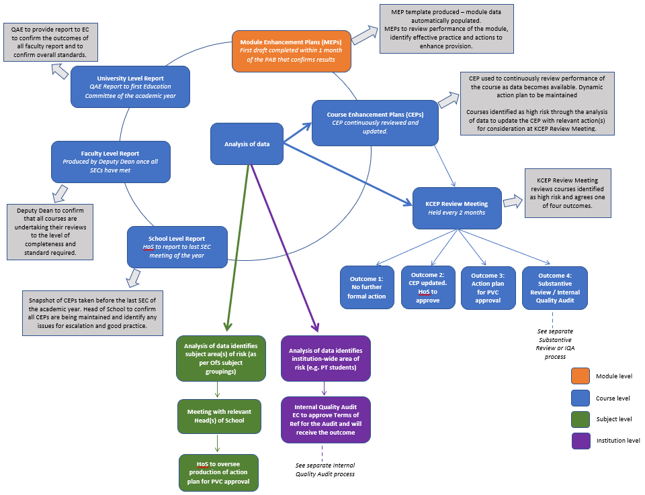

Appendix 3

Overview of course level continuous monitoring and enhancement

