External Examiner Module Materials – Guide for Kingston University Academic Staff
External examiners are granted access to the University’s External Examiners’ Reporting System (EERS), Canvas (virtual learning environment) and SharePoint/ OneDrive (file sharing system).

The Quality Assurance & Enhancement team send each external examiner a unique KU number, instructions on how to set up their password, a guide to Kingston University systems and guidance on setting up Multi-Factor Authentication, prior to commencing their duties.

Subject external examiners are automatically enrolled onto the Canvas modules for which they are responsible according to the allocations in SITS.

It is important that:
- Course teams/ Module Leaders check that their external examiner has access to the module materials on Canvas during the annual schedule of work meeting and again prior to the module ratification period.
- External examiners are provided with instructions on how, where, and when to access the relevant materials and sample of student work in a timely manner.

Canvas
All module materials should be shared with your external examiner(s) via Canvas where possible, including:

- Information about the module (Canvas module guide, current validated module descriptor, Module Enhancement Plan).
- Assessment (links to assessment briefs, marking criteria/ mark schemes, assessment rubrics).
- Sample of internally moderated student work (indicated using the ‘Notes’ column in Canvas Gradebook), including evidence of internal moderation.

SharePoint/ OneDrive
Draft assessments (coursework briefs/ examination papers) and model solutions must be shared with external examiners via a private SharePoint folder which will be created automatically using the Canvas OneDrive LTI.

Please follow these instructions to set up the private ‘External Examiners’ folder:


- Click on the Apps filter and select the ‘Microsoft OneDrive’ option.
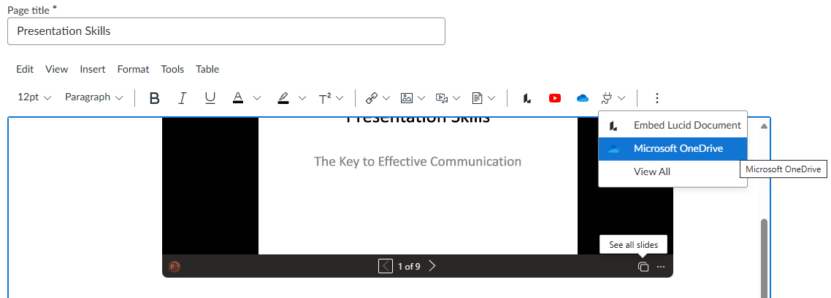
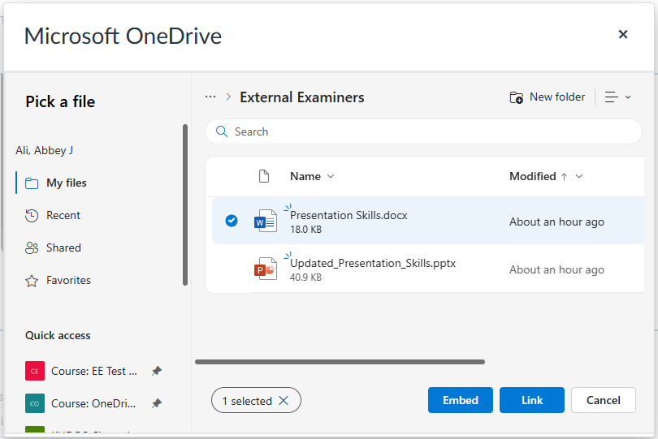
- Select your file to upload into Canvas from the ‘Pick a file’ option in your OneDrive (this will trigger the creation of the SharePoint Site).

- Select Embed or Link.
- Complete the rest of the details on the Canvas Page, Save and if required Publish as you normally would.
- Check the File link or the embedded document in the page, to ensure that it is working.
- In your Outlook email you will receive an email confirmation from the ‘Flow Service Account’ with the link to the SharePoint Site. (please note: this can take up to 2 hours as the process runs every two hours).
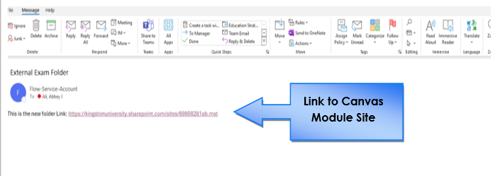

To find the ‘External Examiners’ folder and share it with your EE(s):
- Click on the link in your Outlook email to open the SharePoint Site.
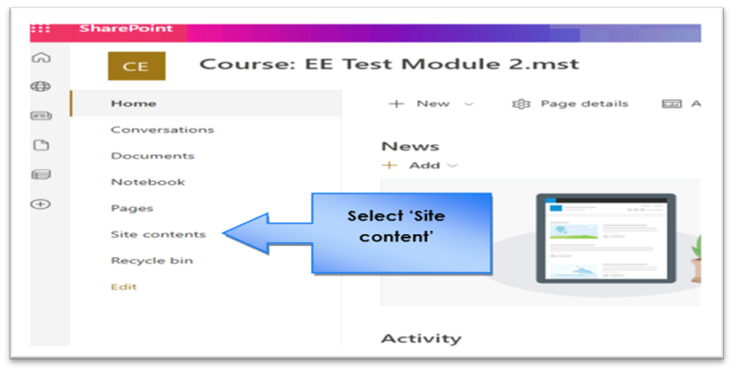
- On the left-hand side, select ‘Site contents’.
- This will open up the Contents library and you will have a list of various libraries. Select ‘OneDriveLTIFiles’

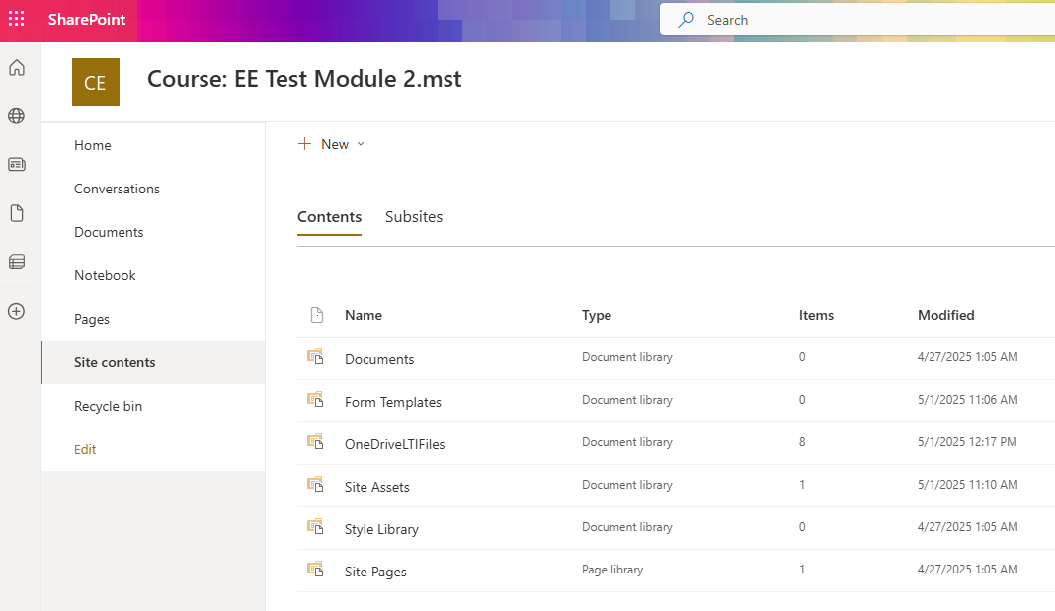

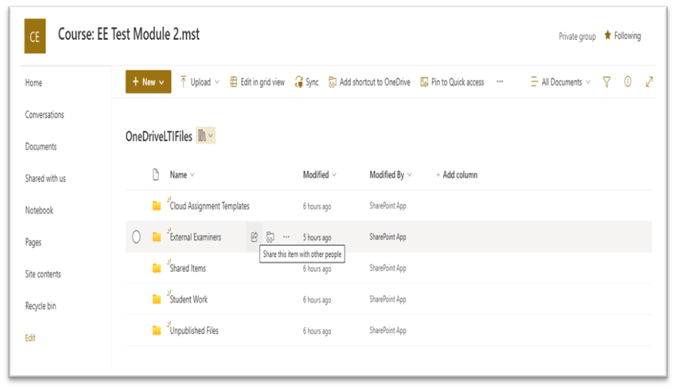

- In the OneDriveLTIFiles, you will find the ‘External Examiners’ private folder.
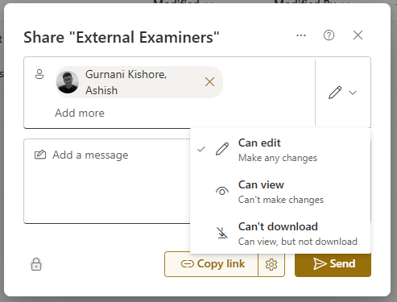
- Select the Share Icon and add your External Examiner to the folder using their KU email address.
Following a SharePoint site
Following shows all the sites you follow, such as your team site or a site from another group you work with. To stop following a SharePoint site, select the filled-in star to unfollow. Select See all to view more followed sites.
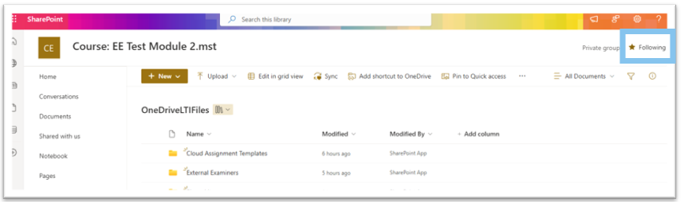
Once you follow a site, you will then see the site in your SharePoint homepage on the left-hand side.
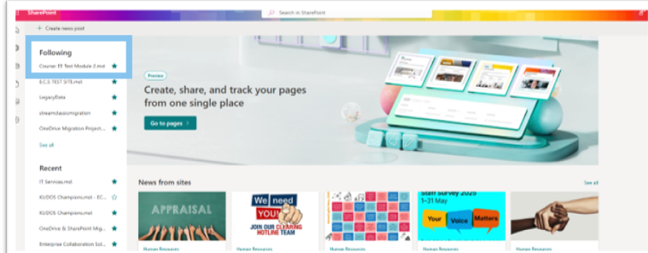
You can also add the OneDriveLTIFiles as a shortcut to OneDrive. Please see Add shortcuts to shared folders in OneDrive

Download a Word version via the Curriculum Management System. Link to video tutorial: How to download a Module Descriptor from the CMS.webm.
Download a PDF copy via the Annual Monitoring and Enhancement SharePoint site. Link to video tutorial: How to download the Module Enhancement Plan from the AME site.webm.
Link to video tutorial: Canvas Guidance: The Gradebook: Support for Academic Staff (kingston.ac.uk)

